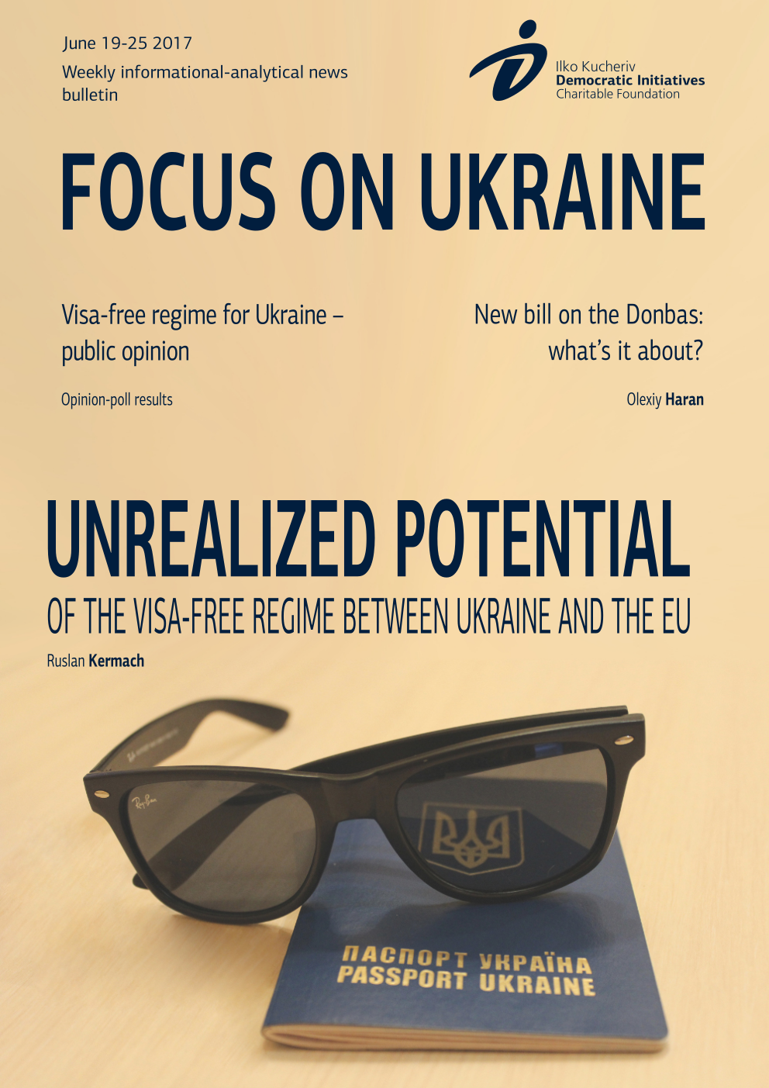

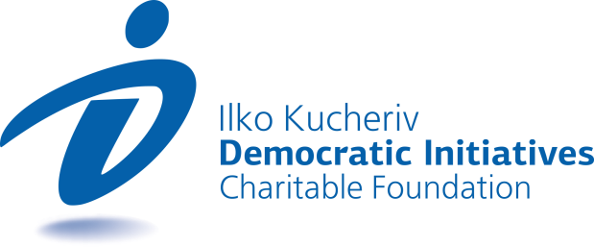

TOPICS
UNREALIZED POTENTIAL OF THE VISA-FREE REGIME BETWEEN UKRAINE AND THE EU 3
NEW BILL ON THE DONBAS: WHAT’S IT ABOUT? 5
VISA-FREE REGIME FOR UKRAINE – PUBLIC OPINION 7

UNREALIZED POTENTIAL OF THE VISA-FREE REGIME BETWEEN UKRAINE AND THE EU
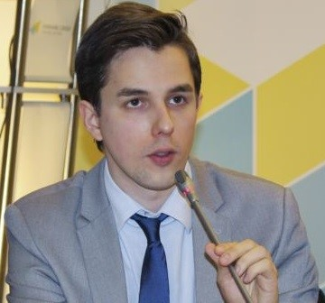  Ruslan Kermach  Political analyst, Democratic Initiatives Foundation | Starting from June 11 of this year Ukrainian citizens that have in hand a biometric foreign passport will finally be able to freely travel within the framework of short-term trips (up to 90 days every 180 days) without the need to obtain a visa to enter countries of the European Union and four other European countries, which are not EU member-states (Iceland, Lichtenstein, Norway and Switzerland). Therefore, the near 10-year saga of complicated and contradictory talks between Ukraine and the European Union regarding the simplification of the visa regime has come to an end.
According to the information of the State Border Guard Service of Ukraine, over the first week 18,000 Ukrainian citizens managed to take advantage of the functioning of the visa-free regime.
It is quite clear that in the foreseeable future many more thousands of Ukrainians will take advantage of the possibility to travel to countries of Europe without a visa, though at the same time the unrealized potential of the new visa-free regime could turn out to be much more significant.
According to the results of the nationwide polling recently conducted by the Ilko Kucheriv Democratic Initiatives Foundation (DIF) jointly with the Razumkov Center, only 7% of citizens of Ukraine managed to obtain new biometric passports, which give them the right of visa-free travel to countries of the Schengen Area. Approximately the same number – 7.4% of Ukrainians – is only planning to apply for a biometric passport over the course of this year. Given this, approximately every seventh Ukrainian citizen will be able to take advantage of the “visa-free” advantages in the nearest future, which however is not a sufficiently convincing indicator.
Particularly notable is the contrast on the backdrop of approximately 45% of Ukrainians, who according to data of the aforementioned polling are totally not planning to apply for a biometric foreign passport, while the absolute majority of citizens (66%) admitted that they do not have a foreign passport of any kind whatsoever. At that, in the context of the latter the situation looks fairly similar in different regions of the country: in each of the macro-regions of Ukraine (West, Center, East, South) the overwhelming majority of citizens do not have a foreign passport at all.
Such a grim picture being formed through the prism of public opinion in Ukraine could testify first and foremost to the fairly low level of the cross-border mobility of Ukrainian citizens in the context of their going on short-term trips abroad to European countries. In truth, this situation is not surprising if to take into account that Ukrainians did not travel that actively in their own country. For instance, the results of public opinion poll of the Kyiv International Institute of Sociology (KIIS) conducted some years before showed that 36% of Ukrainians did not even travel beyond their region of residence.
It practically does not incite any doubts that today the decisive factor inhibiting the mobility of Ukrainian citizens from traveling abroad is their financial wherewithal and their general level of income. The sharp decline in the economy of Ukraine, an almost threefold devaluation of the national currency (hryvnia) and multiple hikes in municipal residential utilities services over the past several years had a negative impact on real incomes of the majority of citizens and accordingly on their financial ability to take short trips to countries of the European Union.
For example, more than 60% of citizens noted a worsening of their material situation over the past year according to the results of polling conducted in May of this year by the sociological group “Rating”.
The economic factor finds its logical reflection in the plane of the self-esteem of Ukrainian citizens, the absolute majority of which (59%) expressed in the public opinion poll their conviction that can feel themselves as genuine Europeans mainly upon reaching a certain level of well-being. Herewith, such an approach in general is shared by citizens of all regions and age groups.
At the same time, it would be wrong to presume that material considerations are the only factor that constrains the cross-border mobility of Ukrainian citizens. The other side of the coin of “visa-free obstacles” is the real awareness of citizens regarding the new rules and possibilities that the new regime of crossing the borders with European countries affords them.
Given this, according to the already mentioned results of polling of the Democratic Initiatives Foundation (DIF) more than a third (35%) of citizens generally know nothing about the rules of entry and stay in countries of the Schengen Area, while even more Ukrainians (nearly 38%) are either unsure or have an absolutely erroneous perception of the fact that a visa-free regime with Schengen countries ostensibly grants them the right to work in the respective countries.
Another similar sociological study of the Kyiv International Institute of Sociology (KIIS) showed that only every fourth citizen of Ukraine knows over which term he/she is allowed to stay on the territory of the EU according to the terms of visa-free regime, while at the same time only every third polled in Ukraine knows about the need to have a biometric passport for visa-free travel to the EU.
Thus, besides focusing on the tangible improvement in the material standing of citizens, the governmental bodies, representatives of civil society in Ukraine and all other interested players must in the foreseeable future make systemic efforts to enlighten and duly inform different segments and age groups of Ukrainian citizens about the basic principles of the functioning of the visa-free regime, the main rules of entry and stay in the Schengen Area countries and other tangential aspects in order for the visa-free regime with the EU to be perceived as truly “victorious” achievement in Ukraine.
Particular attention in the context of a nationwide information awareness campaign in Ukraine regarding the “visa-free regime” must be paid to youth and students as the most dynamic and mobile segment of Ukrainian society. The support of short-term (up to 90 days) educational programs and the organization of trips to EU countries with the aim of cultural enlightenment by the state and foreign donors for this segment of the population would also be totally expedient. Together with this it would be worthwhile orienting separate efforts towards the improvement of conditions for Ukrainians of different age groups to learn foreign languages, in particular English, in Ukraine. Such a policy could in the future foster the improvement of the situation with the cross-border mobility of Ukrainian citizens.
Introduction of the visa-free regime is only the first extremely important step towards rapprochement of Ukraine with countries of the European Union. However, no less important work lies ahead. Specifically, it should be aimed at giving the greater part of Ukrainian citizens not only the rights, but also the possibilities and the necessary knowledge (awareness) that will allow them to freely and regularly travel to countries of a united Europe.
Оriginal: Ukrainian Interest

NEW BILL ON THE DONBAS: WHAT’S IT ABOUT?
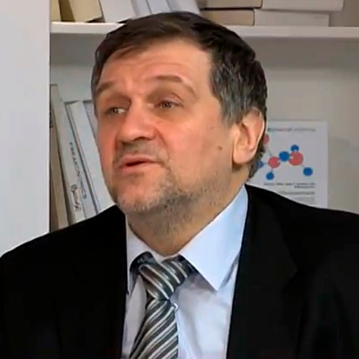  Olexiy Haran  Research Director of the Ilko Kucheriv Democratic Initiatives Foundation | A working group is drafting a bill that would grant status to the temporarily occupied uncontrolled territory of the Donbas. In important detail of the new bill on the de-occupation of the Donbas is the possibility of the declaration of a martial law in certain districts on the frontline.
The majority of experts commenting on the new bill regarding the Donbas believe this to be the right step. Of course, the comments are quite reserved and cautious, including from the parties of the ruling coalition, seeing as the matter is about a document it has yet to see. Thus far even a concept of the bill has yet to be widely available.
On the whole, from what has been said one can highlight two important features. Firstly, the wording “temporarily occupied territories” should have been introduced in this bill a long time ago. Secondly, the format of the ATO zone is being changed to a military operation format. This is also correct as the ATO ended back in August 2014 when regular Russian military forces were ushered into Ukraine. Another important aspect of the new bill is the possibility of the declaration of a martial law in certain districts on the frontline. At the moment, the procedure of declaring a martial law is fixed in the Constitution and registered for the entire country or for separate oblasts. Besides that, this requires approval by the Verkhovna Rada. The new law will make the procedure for introducing a martial law more local and more flexible precisely in those places where there is military action.
This begs the question: To what extent does this bill differ from the one that was introduced by Samopomich? Judging from what the spokespersons of the Petro Poroshenko Bloc say, it appears that in the previous bill they are not pleased with the thesis suggesting that Ukraine does not bear responsibility for its citizens on the occupied territory. It is envisaged that in the VR session hall there will be much debate regarding the new bill, but for those factions that call themselves democratic it would be logical to support this bill. It corresponds to that which the military, volunteers, political experts, the opposition parties and the majority of Ukrainian people have been long demanding. So, the majority of the population agrees that this is not an ATO and that it does not make sense to speak about granting “special status”, holding elections on the occupied territory, introducing amnesty, etc.
The international aspect of the bill. Does it contradict the Minsk agreements? It is clear that Russian propaganda would say: of course it contradicts them. Personally, I see no contradiction because the Minsk agreements envisage a stage-by-stage resolution of the conflict: first security, and only then political regulation. At the given moment, everything is stuck at the level of the security issue. Point 1 of the accords – a truce – has not been implemented. For this reason, the current position of Ukraine is acceptable for our Western partners. While earlier they said: “Make amendments to the Constitution, grant “special status” and hold elections”, now it is clear to all sides that this is simply impossible.
Allow me to offer an example. One of the party groups in the European Parliament held a regional conference in Kharkiv. They traveled to Slovyansk in order to see the situation on the spot. One of the variants of the program envisaged a further trip to entry and exit checkpoints on the frontline. But the leadership of the party group strongly advised not to go there due to the high level of risk and in the end nobody paid a visit to these checkpoints. So, the question arises: If it is dangerous to even visit a checkpoint, which a huge number of people pass through every day, then how can one speak of some kind of monitoring of the situation in the Donbas by international observers for the holding of elections? This is absolutely impossible. Another interesting question: How is this all related to the visit of President of Ukraine Petro Poroshenko to Washington? Did he go there to coordinate this document with U.S. President Donald Trump? Ukrainian sources confirmed that it was discussed. But it is difficult to imagine a situation in which this bill would be rejected after it was announced. I think the process has gone forward, though certain details and wordings of the bill can be clarified with Ukraine’s Western partners.
Original: Новое время (Novoye vremya - New Times)

VISA-FREE REGIME FOR UKRAINE – PUBLIC OPINION
Ilko Kucheriv Democratic Initiatives Foundation  Public opinion poll results | Nationwide polling of the population of Ukraine was conducted by the Ilko Kucheriv Democratic Initiatives Foundation and the Razumkov Centre from June 9-13, 2017. A total of 2,018 respondents ages 18 and older were polled across all regions of Ukraine with the exception of the Crimean Autonomous Republic and the occupied territories in the Luhansk and Donetsk oblasts. The theoretical margin of error was 2.3%.  Polling was conducted on the financial support of the MATRA Program of the Embassy of the Kingdom of the Netherlands in Ukraine.  For the sake of comparison, data of polling conducted in 2013-2016 by the Ilko Kucheriv Democratic Initiatives Foundation (DIF) in collaboration with the Razumkov Centre and the Kyiv International Institute of Sociology (KIIS) are provided.
- 34% of the population today have a foreign passport (in May 2016 – 30%). Among them 7% have a new biometric foreign passport, 8.5% – an old foreign passport with a valid Schengen visa and 20% – an old foreign passport without a valid Schengen visa. Residents of the West (11%) have the highest number of biometric passports and youth up to 30 years of age (12%). Residents of the East (2.5%) and people over the age of 60 (2%) have the lowest number of biometric passports.
- Among those who do not have a biometric passport, 7% plan to apply for one this year and another 28% are also planning to submit an application for such a passport, but later, and 45% are not planning at all to apply and another 13% are undecided as to whether they need a biometric passport or not. The greatest difference between having a foreign passport and the intention of receiving one is in age: among the generation that is older than 60, around 84% do not have any foreign passport and 78% do not have any intention of applying for such a passport.
- Introduction of a visa-free regime with EU countries is important and very important for 39% of Ukrainian citizens. A visa-free regime is most important for residents of the Western region (53%) and the Central region (44%). It is less important for residents of the South (23%) and the East (25%). The age differences are even more significant: a visa-regime is the most important for youth aged up to 30 years (60%) and the least important – for those over the age of 60 (21%).
- 32% of Ukrainian citizens have the intention of traveling to countries of the Schengen Area, first and foremost, youth (56%). The main purpose of travel is tourism (64%), visiting relatives and friends (22%), working visits (18%), while 22% hope to find gainful employment abroad. The majority of the population (62.5%) knows that a visa-free regime does not give Ukrainians the right to work in Schengen countries, while 15% feel that such a right exists.
- In general, only 14% of Ukrainians feel that they know the rules of a visa-free regime with EU countries and another 50% know somewhat about these rules, but did not especially learn them, and 35% know absolutely nothing about them.
- 38% of Ukrainians consider themselves Europeans, while 55% feel they are not. The highest European self-identity is inherent to residents of the Western region of Ukraine (53%), while in the other regions the feeling of being European is much lower: in the Central region – 37%, in the South – 35% and in the East – 30%. The age differences are considerable: those who feel themselves the most European are the youth – 49% and the least – people of the older generation who are older than 60 years of age – 27%.
- In order to feel European a certain level of material well-being is necessary, first and foremost – 59% of Ukrainians feel this way, while citizens in all regions and all age groups are solidary in this. The feeling of being protected by the law (36%) and respect for democratic values and people’s rights (26%) are in the top three factors that are most important for European identity.
- 57% of Ukrainian citizens support Ukraine joining the European Union in the future, 8% of the population gives preference to a Eurasian Economic Union with Russia, Belarus and Kazakhstan and 25% support non-affiliation with any union. Support of a Eurasian Union (just like other variants of a union with Russia) sharply fell after 2013 – from 30% to 8%, while support of accession to the EU rose – from 42% to 57%. However, at the same time the percentage of those who feel that Ukraine should not join a union neither with Europe nor with Russia rose – from 13% to 25%.
- Support of joining the EU is higher in the Western region (79%) and in the Central region and is lower – in the Southern region (32%) and in the Eastern region (41%), where a considerable share of residents give preference to not joining any of the two unions (43% in the South and 32% in the East).
- As to age differences, youth aged up to 30 years (69%) and in the age group of 30-39 years (64%) supports integration with the EU the most. People of age older than 60 years (41%) support integration with the EU the least, while non-affiliation with any of the two unions has considerable support (35%) in this age group.
SURVEY RESULTS
Do you have the foreign passport? (choose all the answer options that suit you)
I have a new biometric foreign passport | 6,9
I have an old foreign passport with valid Schengen visas | 8,5
I have an old foreign passport, but without valid Schengen visas | 19,6
No, I don't have foreign passport | 66,0
If you do not have the biometric passport, are you going to obtain it this year?
I already have biometric passport | 6,9
Yes, I’m going to obtain it this year | 7,4
I’m going to obtain it, but later | 27,9
I’m not going to obtain foreign passport at all | 45,4
Difficult to say | 12,6

How important is the introduction of the visa-free regime with the EU-countries for you?
Very important | 10,1
Generally important | 28,6
Slightly important | 23,8
Not important at all | 33,7
Difficult to say | 3,8
Are you going to go to any of the Schengen countries?
Yes, definitely | 9,9
Most likely, yes | 22,0
Most likely, no | 17,6
Definitely not | 40,2
Difficult to day | 10,4
If you are going to one of the Schengen countries, then for what purpose?*
% to those, who are definitely or most likely going to go to any of the Schengen area countries
For study, internship etc. | 7,8
Visiting relatives and friends | 21,8
Employment abroad | 22,1
Work visits | 18,1
Tourism | 63,8
Cultural exchange | 7,5
Sports competitions | 1,2
Treatment | 2,4
Permanent residence | 3,9
Other | 1,2
* The response rate is over 100%, since it was possible to mark several answer options

In your opinion, does the visa-free regime with Schengen countries give Ukrainians the right to work in these countries?
Yes | 15,0
No | 62,5
Difficult to say | 22,5

Are you familiar with the rules of entry and stay in the countries of the Schengen Area?
Yes, I got acquainted and I know these rules well | 14,0
I know something but didn’t specifically study them | 50,2
No, I don’t know anything about it | 34,7
Not answered | 1,1

Do you consider yourself a European?
Definitely, yes | 11,0
Rather, yes | 26,8
Rather, no | 29,0
Definitely not | 25,7
Difficult to say | 7,6

In your opinion, what is needed to make you feel a European? Choose up to three answer options
A certain level of material well-being | 58,9
Respect the values of democracy and human rights | 26,2
Be able to go to the European countries without visas | 15,5
To feel yourself protected by law | 36,1
Be able to elect the government in free democratic elections | 12,4
To feel yourself a free person | 16,4
To know foreign languages | 9,9
To know the European culture | 3,7
Nothing is needed, Ukrainians are already Europeans | 10,6
I think there is no need that Ukrainians feel themselves Europeans | 7,2
Other | 1,7
Difficult to say | 5,3
If you had to choose only one option, what Union, in your opinion, should Ukraine join in the long term?
The European Union (EU) | 56,8
The Eurasian Economic Union (EAEU) | 7,8
Should not join neither the European, nor the Eurasian Union | 25,5
Difficult to say | 9,9

“Focus оn Ukraine” – weekly informational-analytical news bulletin prepared by the
Ilko Kucheriv Democratic Initiatives Foundation (http://dif.org.ua).

DIF Analysts:
Iryna Bekeshkina
Oleksiy Haran
Ruslan Kermach
Oleksiy Sydorchuk
Maria Zolkina
Аndriy Sukharyna
Editor-in-chief: Iryna Filipchuk
Cover and layout: Illia Sverhun

