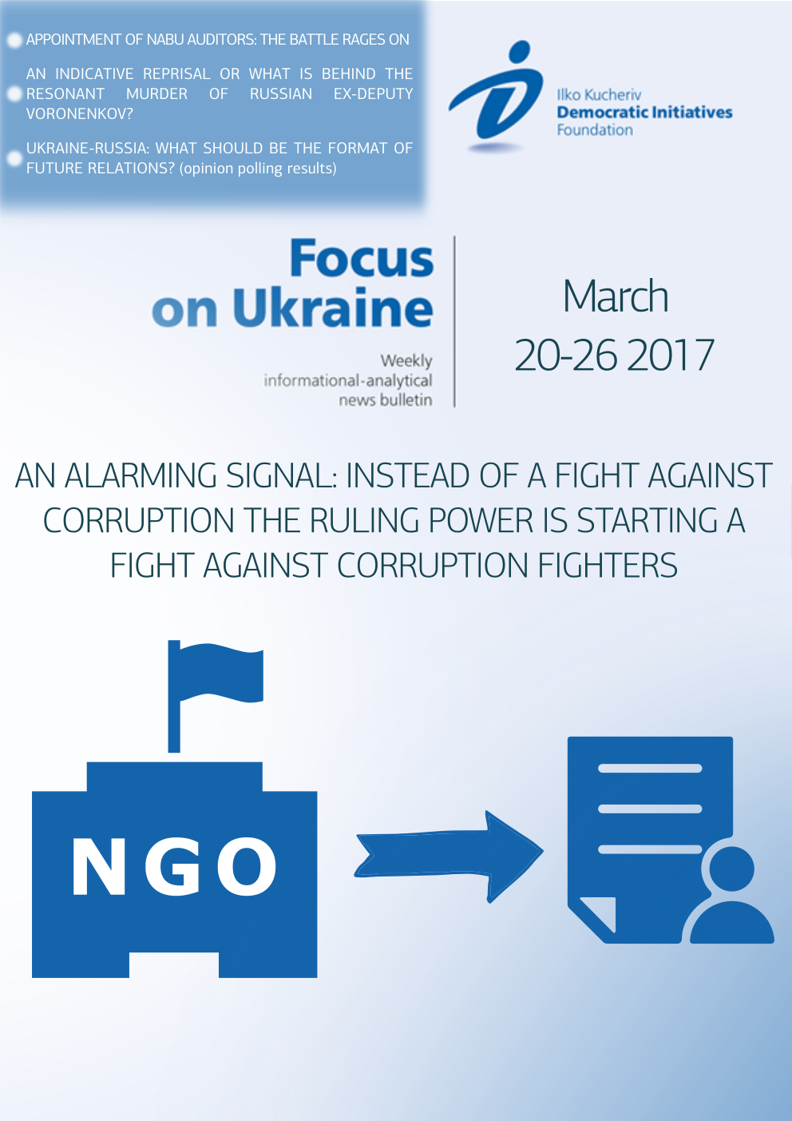

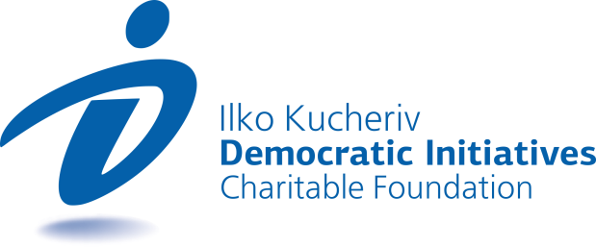
TOPICS
AN ALARMING SIGNAL: INSTEAD OF A FIGHT AGAINST CORRUPTION THE RULING POWER IS STARTING A FIGHT AGAINST CORRUPTION FIGHTERS 3
APPOINTMENT OF NABU AUDITORS: THE BATTLE RAGES ON… 5
AN INDICATIVE REPRISAL OR WHAT IS BEHIND THE RESONANT MURDER OF RUSSIAN EX-DEPUTY VORONENKOV? 6
UKRAINE-RUSSIA: WHAT SHOULD BE THE FORMAT OF FUTURE RELATIONS? 8

AN ALARMING SIGNAL: INSTEAD OF A FIGHT AGAINST CORRUPTION THE RULING POWER IS STARTING A FIGHT AGAINST CORRUPTION FIGHTERS
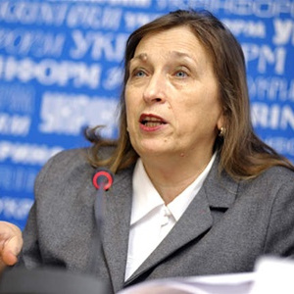  Iryna Bekeshkina  sociologist, Director of the Ilko Kucheriv Democratic Initiatives Foundation | On March 23 the Verkhovna Rada approved in its entirety a presidential bill No. 172 “On Amendments to Article 3 of the Law of Ukraine On the Prevention of Corruption”. In the variant submitted by the President the essence was the exemption of contracted military servicemen and mobilized soldiers from obligations to fill out electronic declarations.  However, in addition to the aforementioned bill an amendment proposed by people’s deputy (People’s Front) Tetyana Chornovil, according to which electronic proprietary declarations in the form envisaged for state public officials must also be submitted by representatives of anti-corruption organizations, was approved. As stated in the Law, anti-corruption organizations included those which “are managers or are part of their senior management, other bodies of management of nongovernment organizations, other non-entrepreneurial companies which are engaged in counteracting corruption, implementation of standards in the sphere of anti-corruption policy, monitoring of the anti-corruption policy of Ukraine, drafting of proposals on issues of formation and realization such a policy and/or take part in and are engaged in taking measures related to the prevention or counteraction of corruption”.
What could the approval of this provision imply? What dangers lie in this provision?
First of all, it is noted that similar appendices to the “Law on the Prevention of Corruption” are legally ignorant seeing as corruption by definition relates to officials of the civil service. The Law of Ukraine “On the Principles of the Prevention of and Fight Against Corruption” succinctly defines corruption as “abuse of official authorities by a person and taking advantage of possibilities related to this with the aim of receiving illegal benefits”. Furthermore, in this law the categories of individuals who are subject of responsibility for illegal acts of corruption are envisaged. Civil activists are not on this list, which is understood seeing as they are employed by the civil service.
Why did deputies violate the law to a certain degree?
The first most obvious reason is revenge. It is non-government organizations, first and foremost those engaged in anti-corruption, which achieved their goal of the approval of the law on electronic declarations in its current form. As a result, society was shocked by the wealth that government officials had earned, including that of deputies who had never been involved in business. However, so far not a single one of the obvious corrupt officials bore any responsibility and the accordant investigations were never launched. Instead, the structures of the ruling power are trying to subordinate anti-corruption bodies, the independence of which those very same non-government organizations are trying to achieve.
Hence, the maximum number of obstacles were put up against the work of non-government anti-corruption organizations and then in turn they were discredited when the opportunity arose.
First and foremost, it must be noted that the provision on organizations that are required to fill out declarations is not very clearly written. And this in turn raises a number of questions: What organizations are they? Are they those whose anti-corruption activity is written in their Statute? Are they those that from time to time are engaged as partners in executing anti-corruption projects? The absence of succinct criteria opens up room for taking a random approach on the part of law enforcement bodies and the persecution of any contentious organizations and non-government activists.
The provision requiring individuals that are engaged in taking measures associated with the prevention or counteraction of corruption should fill out electronic declarations is even less clear. Of course, this provision cuts off anti-corruption organizations from offering certain services, for example, sociological firms that often receive orders to conduct public opinion polls on the topic of corruption or the owners of premises on which public events are conducted or publishers of literature or even the suppliers of office supplies for anti-corruption organizations can refuse to cooperate due to their unwillingness to have to deal with filling out declarations. By the same token, the activity of anti-corruption organizations can simply be paralyzed.
This norm of the Law is essentially targeted against those public activists and organizations that are on the frontline of the fight against corruption.
Not only Ukrainian public (non-government) activists have already expressed their attitudes (see the Statement of the Revitalization Reform Package) - http://rpr.org.ua/news/vlada-zaprovadzhuje-kryminalnu-vidpovidalnist-dlya-uchasnykiv-mitynhiv-proty-koruptsiji-zaklykajemo-prezydenta-ne-dopustyty-avtorytaryzmu/), and our international partners from the European Union and the embassies of the U.S., Great Britain and Canada.
The question lies in herein – is a similar decision of the Verkhovna Rada a consequence of the emotional attitudes of deputies towards anti-corruption organizations and their leaders or is this testimony a targeted policy of the ruling authority, which is beginning to fold the fight against corruption and, hence, take on itself the task of fighting those that are the most fervent fighters against corruption?
The answer to this question will become clear in the foreseeable future. In the opinions of experts, there is only one way out of this situation. The President must veto this bill with proposals attached and return it to the Parliament for consideration. If the President signs this Law in its current form, this will imply a very serious turn of state policy in the direction of folding the fight against corruption and corrupt officials and the start of a battle with civil society.

APPOINTMENT OF NABU AUDITORS: THE BATTLE RAGES ON…
Olexiy Sydorchuk  Political analyst, Democratic Initiatives Foundation | On March 21 the Verkhovna Rada of Ukraine failed to support neither of the candidates for the post of member of the Auditing Commission of the National Anti-Corruption Bureau of Ukraine (NABU). 178 deputies voted in favor of Robert Storch as the Deputy General Inspector of the U.S. Department of Justice, while 202 voted in favor of the British private detective Nigel Brown. The same day a number of non-government organizations proposed to the Cabinet of Ministers of Ukraine a list of three candidates as auditors of the NABU among which the government can select one delegate to the auditing commission. The third member of the commission must be appointed by President Petro Poroshenko.
Voting in the Verkhovna Rada was testimony to the stalemate in the struggle of the informal ruling coalition and the opposition forces composed of Samopomich, Batkivshchyna and certain deputies of the Petro Porosheko Bloc (PPB), who garnered the support of representatives of anti-corruption non-government organizations. In an attempt to appoint the little known Nigel Brown as a member of the auditing commission, the pro-presidential forces most likely had the aim of obtaining control over this commission and gaining legal grounds for the dismissal of the director of the NABU, who of late began showing greater independence from the president and his milieu.
There may be several scenarios of the further course of events. Much will largely depend on the behavior of Poroshenko, whose “quota” in the auditing commission could decide whether or not this body is capable of conducting truly independent audit of the NABU. On the one hand, given the resonance of this matter in society and the dissatisfaction of western partners of Ukraine with the attempts of the parliamentary majority to appoint a candidate that is loyal to it, Poroshenko could make Storch, who has the reputation of a professional and independent expert, his delegate in the commission. The third member of the commission delegated by the government will with a high degree of probability also be an independent figure, meaning that the composite of the commission will be balanced regardless of the decision of the parliament.
On the other hand, the desire to have a leverage over the leadership of the NABU through control over the auditing commission for Poroshenko could prevail over the risk of worsening relations with representatives of western states. Hence, the appointment of a candidate who is convenient for the president to sit on the commission will be corroborate such a scenario. Then the head of state will be able to use his influence on the parliamentary factions in order to prompt them to also select an auditor who is loyal to him. In any case, the behavior of the president will be a signal as to whether or not the ruling power is genuinely interested in the existence of an independent anti-corruption body.

AN INDICATIVE REPRISAL OR WHAT IS BEHIND THE RESONANT MURDER OF RUSSIAN EX-DEPUTY VORONENKOV?
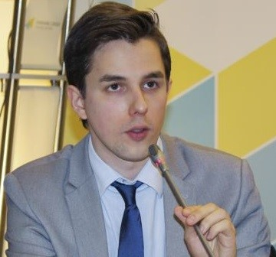  Ruslan Kermach  Political analyst, Democratic Initiatives Foundation | On March 23 ex-deputy of the Russian State Duma Denys Voronenkov was shot and killed in downtown Kyiv near the luxurious Premier Palace Hotel. Voronenkov, who was granted Ukrainian citizenship, moved together with his wife Maria Maksakova, also a former deputy of the Russian parliament, to Kyiv in October 2016. From the moment Voronenkov moved to Ukraine he began harshly criticizing the Russian leadership and actively cooperating with Ukrainian law enforcement bodies. After consulting with representatives of security agencies President of Ukraine Petro Poroshenko called the attack on the Russian politician an “act of state terrorism on the part of Russia”.
The version of the possible complicity of the Russian special services in the murder of the former Russian MP Denys Voronenkov was taken by Ukrainian law enforcement bodies as the basis for the investigation not by accident. The fact that Voronenkov worked in the Russian special services (Russian Federal Service for the Control of Drug Trafficking) and at one time was in the inner circle of the upper echelon of power in Russia prior to his move to Ukraine could indirectly point to the serious concerns of Moscow about the activeness of the defector to Ukraine and, in particular, his potential capacity to shed light on those crimes in which the higher political leadership of Russia was complicit.
It was also widely known that the recently murdered Voronenkov actively collaborated over the past several months with Ukrainian investigative bodies and seemingly provided the Prosecutor General’s Office of Ukraine with valuable testimony in the affair concerning the state treason of former Ukrainian President Viktor Yanukovych. Thus his face-to-face testimony could have had certain significance for Ukraine’s law enforcement bodies within the framework of a judicial review of the respective case, while for the Russian authorities the activity in Ukraine of an ex-deputy fugitive who was sufficiently aware of matters in the Russian “power kitchen” could have been a major irritant or even a threat to state interests. In short, Voronenkov was not simply an ordinary ex-deputy of the Russian State Duma, but once an important representative of the elite caste of the Russian special services.
Alongside that, the reputation of Voronenkov, who according to certain testimonies during the times he lived in Russia was mixed up in different forms of financial racketeering schemes, also gives certain grounds to assume that the motives for his murder could have been much more prosaic and were directly connected to his financial machinations in his homeland the responsibility for which he decided to evade by taking shelter in Ukraine. As is known, in Moscow investigations were being conducted against Voronenkov in connection with the seizure of buildings through raid tactics. Therefore, a whole band of agents whose roads the former Russian high-standing official may have crossed in his time could potentially have existed. In addition to that, many today express a totally fair presumption that precisely this interpretation of the motives for the sensational murder could be convenient for the Russian authorities in order to divert main suspicion from themselves. Be that as it may, such a version cannot be totally ruled out at the current stage.
Regardless of the real motives for the murder of the former Russian deputy-émigré Voronenkov, there is practically no doubt that the Kremlin will try to gain additional political benefits from this episode. On the one hand, the fact itself that committing such a provocative murder right in the heart of the Ukrainian capital directly undermines the trust in Ukraine’s law enforcement bodies and forces us once again to doubt their capability of effectively counteracting sabotage terrorist activity of the Russian special services or common criminals on the territory of Ukraine. Further, this resounding murder could become a reason for potential political emigrants from Russia to never again dare to choose Ukraine as a safe place for political asylum. This, in turn, limits the potential circle of key witnesses accessible by Ukrainian investigative bodies in the context of investigations into those or other crimes in which Russian officials are or might be complicit.
On the other hand, the resonance and publicity of reprisals against once fairly influential representatives of the Russian power system became a strong signal or even a warning sign for the current representatives of the close to Kremlin political elite or special services who could potentially consider the possible variants of a “way out of the game” or political emigration from Russia for one reason or another. In this way a sensational murder case can at best serve the aim of the Kremlin to consolidate its own “shaky” representatives of the political elite in conditions of the instability or the possible weakening of the Russian political regime in the future.

UKRAINE-RUSSIA: WHAT SHOULD BE THE FORMAT OF FUTURE RELATIONS?
Ilko Kucheriv Demokratic Initiatives Foundation  Opinion polling results | Research conducted by the sociological service of the Razumkov Center jointly with the Ilko Kucheriv Democratic Initiatives Foundation from December 16-20, 2016 in all regions of Ukraine, with the exception of Crimea and the occupied territories in the Donbas and Luhansk oblasts. At total of 2,018 respondents ages 18 and above were polled, The theoretical margin of error does not exceed 2.3%.  The polling was conducted with the support of the MATRA project of the Embassy of The Netherlands.
- Nearly half of the population of Ukraine (49%) feels that the normalization of relations between Ukraine and Russia is possible, but only in the distant future. People in the Donbas region (63%) and in central Ukraine (52%) believe the most that in the distant future the situation between the two countries will be normalized, while people living in the western and southern regions of the country believe in this the least (43% and 42% respectively). At the same time, only every tenth Ukrainian surveyed believes in the possibility of normalization of bilateral relations between Ukraine and Russia in the foreseeable future (10%), while nearly one fourth of Ukrainian citizens (24%) do not believe in such prospects. In the western regions of Ukraine 38% of the people are convinced that normalization of relations with Russia is impossible, while in the Donbas region only 15% of the population feels the same way. Finally, 17% of the respondents all over Ukraine were undetermined about their opinion regarding the prospects of normalization of relations between Ukraine and Russia.
- The majority of Ukrainian citizens are convinced that the normalization for relations with Russia is possible first and foremost on conditions of a change in power (i.e. the president) in Russia (47%), the cessation of military actions and de-occupation of the Donbas region (43%) and the return of the annexed Crimea to the jurisdiction of Ukraine (31%). In comparison, an insignificant part of the surveyed Ukrainian citizens believe that the normalization of relations with Russia will happen if pro-Russian politicians and political forces come to power in Ukraine (8%), without any conditions (8%) or on condition of increased pressure on Ukraine on the part of western countries in this vector (5%). Alongside, 15% of the surveyed could respond at all on the issue of the conditions on which the normalization of relations with Russia is possible.
- The most supported variant of Ukraine’s policy towards Russia (35% of the population surveyed) at the current stage envisages maximum limitation of contacts, suspending any form of collaboration, preserving the sanctions against Russia and introduction of the visa-free regime for Ukrainian citizens. The support of citizens of this variant of government policy is the highest in the West (54%), while support of citizens living in the South and East of Ukraine is the lowest (24%). Slightly more than a fourth of Ukrainians (28%) support the variant of limited cooperation in highly critical spheres, preservation of contacts and maintaining bilateral dialog, but they feel that delineating the so-called “red lines” of a compromise is impossible.* Only 15% of the surveyed are ready to justify the search for any compromises with Russia with the aim of regulating the conflict and returning to amicable partner relations. In any case, those that are most oriented towards finding a compromise with Russia live in the South (30%) and in the East (29%), while in the West and Center of the country only 5% and 7% of the surveyed, respectively, support this idea. A significant part of the surveyed (21%) was undetermined as to the best way that Ukraine can interact with Russia in the current conditions.
* The “red lines” are the limits for compromise in the spheres of political dialog, security, and humanitarian issues that should not be crossed by Ukraine within the framework of the implementation of the Minsk Agreements.

“Focus оn Ukraine” – weekly informational-analytical news bulletin prepared by the
Ilko Kucheriv Democratic Initiatives Foundation (http://dif.org.ua).

DIF Analysts:
Iryna Bekeshkina
Oleksiy Haran
Ruslan Kermach
Oleksiy Sydorchuk
Maria Zolkina
Аndriy Sukharyna
Editor-in-chief: Iryna Filipchuk

