Research of the Status
of Female Veterans
and Services Provided to Them

Final Report

Research period: 16 December 2019 – 15 March 2020

March – 2020

Research team:

Iryna Bekeshkina, Candidate of Philosophical Sciences, Director
Yurii Horban, Project Coordinator
Andrii Sukharyna, Analyst
Petro Burkovskyi, Analyst

This Report has been prepared by the Ilko Kucheriv Democratic Initiatives Foundation following the research of the status of women veterans and services provided to them conducted at the request of the East Europe Foundation within the “All4One: comprehensive program of psychological and mentoring support for veterans” project implemented by the East Europe Foundation with support of the British Embassy in Ukraine.

The opinions and statements expressed in this publication are the sole responsibility of the authors and do not necessarily reflect the stance of the United Kingdom Government.
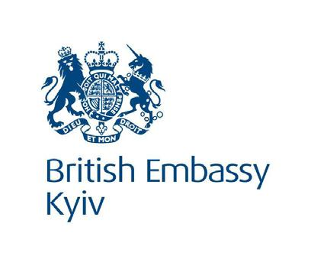

CONTENTS
I | INTRODUCTION 4
II. | RESEARCH METHODOLOGY 5
ІІІ. | RESEARCH FINDINGS AND RECOMMENDATIONS 7
ІV. | ANNEXES 16

I. INTRODUCTION
Managing the fallout from the war in Donbas requires consolidated efforts of the state and the civil society. Effective addressing of new, previously unknown problems should be based on accurate data obtained and validated using scientific and analytical tools.
This is especially true for such a politically sensitive topic as the adaptation to a peaceful life of the service personnel who served in the ATO/JFO. Although the Government has approved the State Target Program for Readaptation of ATO Veterans, and various privileges and types of assistance have been enshrined in the laws, the public constantly faces the facts revealing problems with the implementation of that provision in life.
However, the public turned their back to the problems of women veterans. This can be due to the fact that women make a minority among the service personnel. This fact was pointed out by Government Commissioner on Gender Policy Kateryna Levchenko, who noted that the above State Target Program for Readaptation of ATO Veterans Until 2022 did not take into account the interests of 12 thousand female participants of ATO. Moreover, the previous research of our colleagues with the speaking name “Invisible Battalion” has shown that attitude to female military personnel in the army is largely based on the inertia and stereotypes of the Soviet era.
Thus, the purpose of the Ilko Kucheriv Democratic Initiatives Foundation was to study the problems, needs and requests of women veterans of ATO/JFO and to obtain feedback from them on how effective the existing social adaptation measures are.
This research aims to provide evidential grounds for inventorying and reviewing all services in the regions with a gender perspective, identifying gaps in their provision, planning and introducing new services; developing systems to effectively inform about the services and refer customers to relevant services or specialists; creating tools to monitor and evaluate the model.
Based on the research in three pilot regions, namely Dnipropetrovsk, Donetsk and Lviv, a service model will be developed integrating available and proposed new services.
The results of the research and the recommendations made were presented on 12 March 2020 at the Ukrinform news agency with the participation of representatives of veterans' organizations, representatives of the Ministry of Veterans Affairs, Temporarily Occupied Territories and Internally Displaced Persons of Ukraine, the East Europe Foundation and the British Embassy in Ukraine.

II. RESEARCH METHODOLOGY

The research included the following components:
- Arrangement of focus groups in target regions (Lviv, Dnipropetrovsk and Donetsk).
- Collection of primary information through online survey of women veterans in target regions.
- Preparation of analytical report and recommendations for social services specialists and practitioners.
In December 2019 - January 2020, local authorities and NGOs, in close cooperation with the Ministry of Veterans Affairs, Temporarily Occupied Territories and Internally Displaced Persons of Ukraine, carried out the preparatory work necessary for the field research stage: compilation of lists of women veterans, selection of women for focus groups, development of focus group guides, and a survey questionnaire.
For this purpose, preparatory trips were made to three target areas, namely Lviv, Donetsk and Dnipropetrovsk. Purpose of the trips: to establish contacts with stakeholders, collection of preliminary data on major problems/needs of women veterans, and cooperation with local stakeholders.
The focus group guide and survey questionnaire were developed in cooperation with an expert group consisting of sociologists, psychologists, and NGO representatives who had an experience in working with ATO women veterans.
Three focus groups were conducted in January-February 2020: in Lviv, Dnipro and Mariupol. Focus group participants were randomly selected from the lists developed jointly with the Ministry and the East Europe Foundation. Each focus group consisted of 8-12 women veterans. The groups included residents of both the regional centre and the small towns and villages in the target regions. The focus group discussion time was about 120-140 minutes. All discussions were audio recorded under condition of participants’ anonymity. Participants of each focus group were free to choose the Ukrainian and/or Russian language of communication.
In order to achieve a greater openness, the focus groups were moderated by a woman, namely by Director of the Democratic Initiatives Foundation Iryna Bekeshkina.
Along with the focus groups, online surveys began in three pilot regions - Lviv, Dnipropetrovsk and Donetsk. The respondents were selected from among residents of the regional centre, small towns and villages. The aim was to interview at least 75 women veterans from each region and achieve a total of at least 225 respondents.
During the research, the Foundation team had to review the survey options toward increasing the total number of respondents and increasing the number of regions. The main reason for changes in the online survey was the fact that questionnaires were coming from the target regions unevenly. As a result, it was decided to extend the survey period to 3 March.
As a result, a total of 763 questionnaires were collected, of which 527 respondents had already returned from the JFO area. The survey allowed to identify and analyse trends in the opinions of women participating in hostilities. Some questions highlight the differences between the respondents who are now outside Donetsk and Luhansk regions - that is, those who have already left the conflict zone and returned to a peaceful life. However, its results cannot be extrapolated to the entire veteran community, as no one has accurate information on the number and settling of women veterans in different regions.
For the purpose of an expert assessment of the status of problems and difficulties faced by local authorities in the issues of readaptation of ATO veterans, 10 (ten) in-depth interviews (three in each of Lviv and Dnipropetrovsk regions, and four in Donetsk region) were conducted with representatives of local authorities - officials of local branches of the Ministry of Veterans Affairs, city centres for assistance and provision of services to veterans, veteran volunteers and representatives of veterans' organizations.
Based on the data obtained in early March, analysts of the Democratic Initiatives Foundation prepared this Report and recommendations, taking into account the materials of the expert group of the All4One project of the East Europe Foundation and the opinions expressed during the in-depth interviews.

ІІІ. RESEARCH FINDINGS AND RECOMMENDATIONS

During the focus group, many women veterans emphasized that they had no particular social or legal problems as compared to men. Now, most of the experts surveyed shared this opinion.
Women veterans who participated in the research noted that, in case of public declaration of their status (combat veteran) and appeal to their right to privileges, they would become an object of condemnation and hostility on the part of the majority of citizens who neither perceive the reason nor the content of such privileged status. Therefore, many veterans hesitate to declare their status.
Second, veterans cited numerous examples demonstrating that the army still had a biased attitude towards women. The answers of the group participants suggested that health and gender issues were often used by the leadership to discharge women from military service. In addition, women veterans often did not receive well-deserved promotion and adequate support because of the sexist attitude of the leadership of military units.
Women veterans noted that the services provided to veterans largely depended on the attitude of the city (district, region) leadership. In particular, the city authorities provide better assistance to veterans registered in Dnipro, Lviv and Mariupol than the assistance received by veterans in the respective regions. At the same time, the general attitude of the authorities to veterans in Kryvyi Rih and Donbas is extremely hostile.
Participants of the groups noted the neglectful, superficial and hostile attitude of local authorities to their needs, corruption in institutions engaged in veterans' affairs.
Incompetence of Oschadbank employees responsible for payments to veterans was commonly mentioned. Benefit, housing or land allocation issues could be addressed promptly only through bribery of officials who, in turn, openly or indirectly demand bribe. It is about the regional state administrations, local social security departments and military registration and enlistment offices. This attitude of local officials was repeatedly mentioned in all three focus groups.
According to women veterans, localized handling of issues of social assistance will bring zero result. Any pragmatic solutions will be blocked because of: 1. shortcomings in the entire regulatory system governing the service in the army; 2. army and ministerial bureaucracy; 3. low moral and professional qualities of military commanders at all levels. The participants noted that good commanders are the exception, and surely there are no such commanders among the generals.
The focus groups showed that women veterans had a growing concern that the state would keep on disengaging from veterans and the veteran movement from 2019, and that the media would work to discredit the image of veterans and to form a negative attitude to them in the society.
The participants of the groups noted that even active struggle for their rights and publicity had not yielded any practical and desired results. This leads not only to disappointment with their activities, but also to a loss of trust in the state.
The findings of the survey of women veterans across the country allow us to have a better idea of how deep and big certain problems are to give more accurate recommendations.
In particular, most of the respondents noted that the situation in their life after returning from the front was relatively favourable. However, an important fact is that nearly 15% of those surveyed say the situation is bad or even critical.
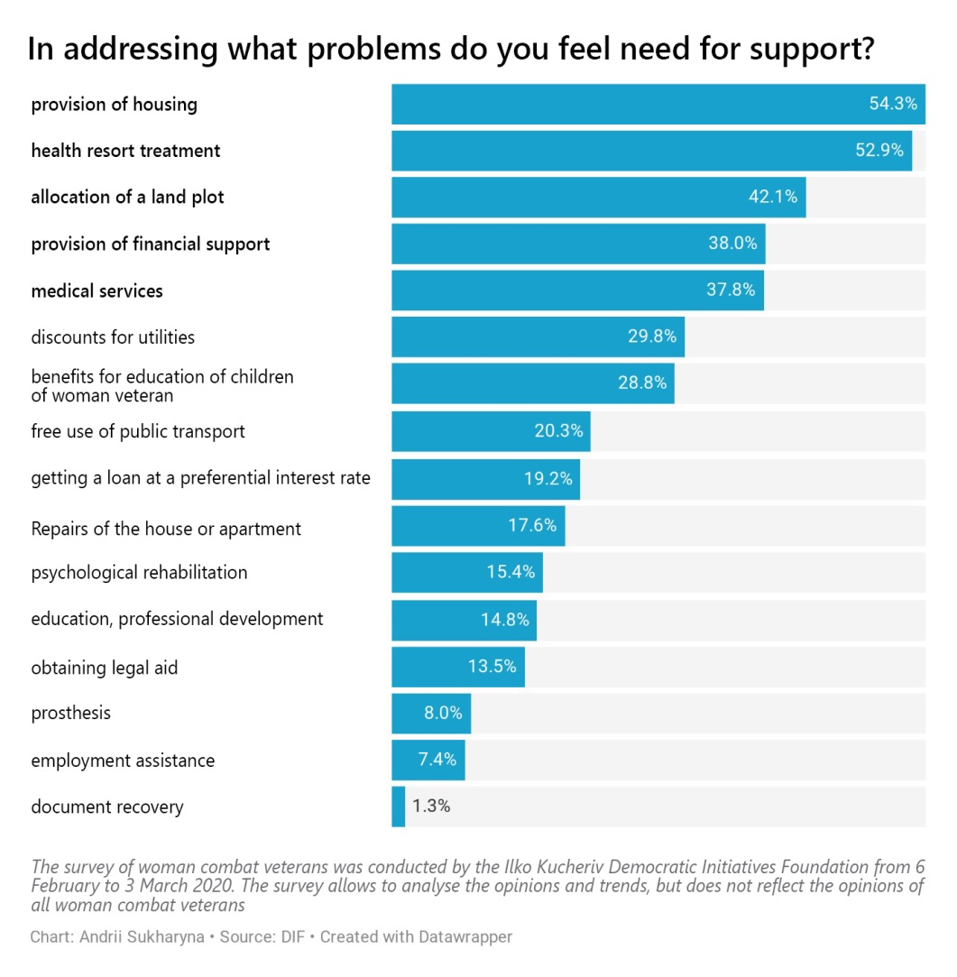

Housing and health problems are the top ones mentioned by women who have returned from the ATO/JDO area.

Employment situation
- Most of the woman combat veteran surveyed are now military personnel and police officers. Accordingly, they are less concerned with the employment issue. However, when it comes to those who are not currently in the service, there are a number of job search related issues.
- More than 8% of respondents who have returned from Donetsk and Luhansk regions currently can not find a job. Also, another 12% are unable to work for objective reasons (such as child care or inability to work because of health reasons). The most critical situation is observed in the group of women who have returned from Donbas and are not in the military service. Only a third of them had no difficulties with employment, while the rest faced difficulties of varied nature.
- Also, poor job search assistance is observed. More than half of the respondents who sought assistance in finding a job did not receive such assistance.
- Nearly half of surveyed people among those who returned from Donbas would like to continue their military careers. Only a quarter of those surveyed do not want to stay in the armed forces, and about the same number hesitate to answer.
- Among those who wish to continue their military careers, about a third already have military education and half would like to obtain it.

Health care
- About half of the respondents had no major health problems related to the service in the ATO/JFO area. However, a significant proportion of respondents still faced major health problems.
- More than a quarter of those surveyed suffered from progress of diseases that had suffered before. Every fifth suffered severe psychological stress. More than 10% said they had a serious chronic disease. In fact, these figures are very high as they show that almost half of the combat veterans actually have significant health problems.
- When it comes to the need for medical care, 15% of those surveyed need it. Also, almost half of those surveyed said it was desirable to get medical care to address minor health problems or prevent them.
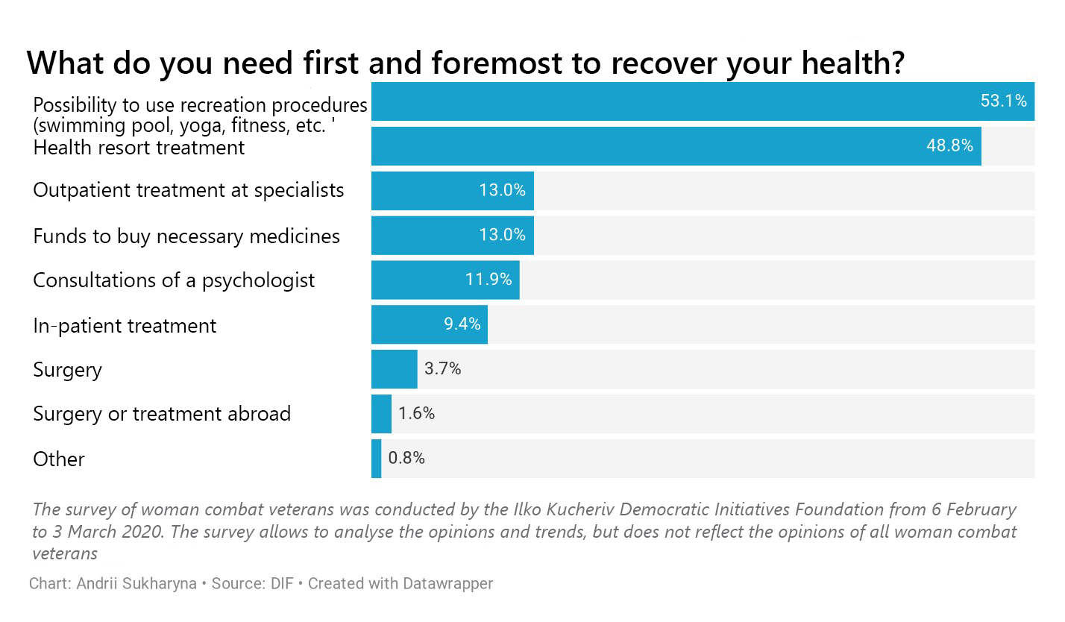
- Medical assistance that female veterans need is mostly of preventive and precautionary nature. First of all, it is a possibility to use recreation services and health resort treatment. Timely and high-quality prevention often helps to protect yourself from complications and chronic conditions. At the same time, almost 20% of those in need of medical care say they need assistance in purchase of medicines.
- Most women veterans say they need advice or treatment from a vertebrologist, neurologist and dentist.
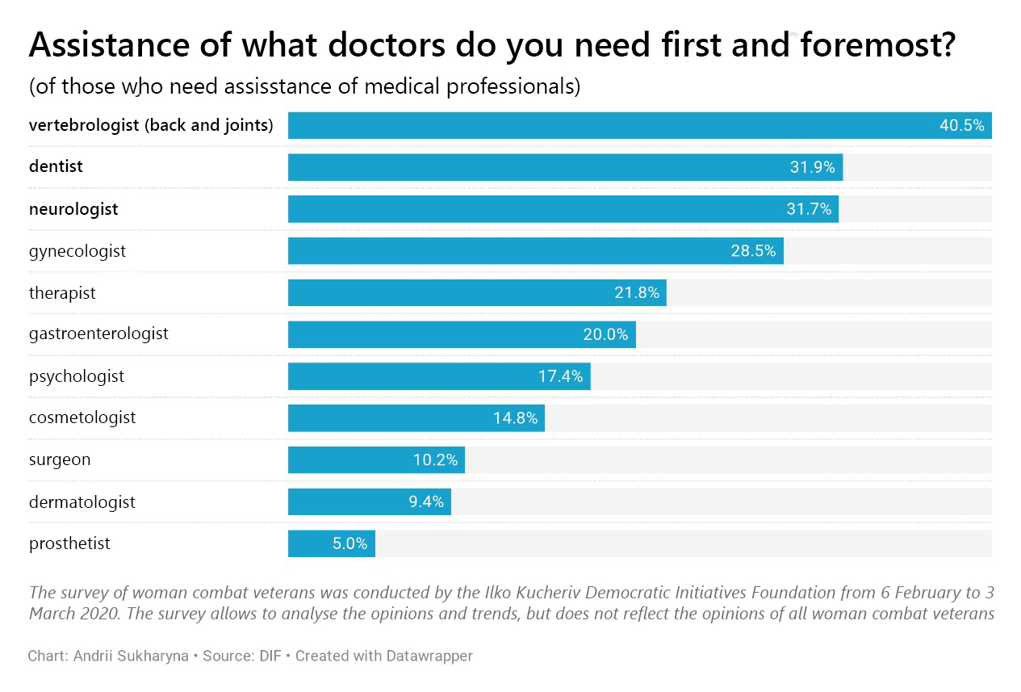
- Only a third of those surveyed did not seek medical care after they had returned. At the same time, more than 10% of respondents apply for such care regularly.
- Most respondents were generally satisfied with the medical services they received. However, about a quarter said they were not satisfied with the level of health care. The main complaints include low competence of doctors and the need to pay for those services that are supposed to be free.
- More than half of the woman combatant veterans who returned from Donbas had psychological difficulties one way or another. The main reason is that people do not understand their life stance and values.
- Among those who had difficulties in psychological adaptation, a little more than a quarter sought counselling. At the same time, almost half of them suggest they will do that in the future. 20% of respondents are sceptical that counselling can be helpful.
- A third of those who sought help were completely satisfied with counselling, and only 15% of the woman combat veterans surveyed stated that counselling was not effective.
- Among those who were not fully satisfied with counselling, the majority claimed that counselling specialist was not well-aware of specifics and concerns of veterans.
- According to veterans, counselling should be not in groups but rather individual consultations, and counselling to veterans should be provided by specialists who have been in the field and know how does it feel to be there.
Living conditions
- The housing issue is one of the most critical problems for veterans. More than a third of those surveyed rent housing, some live with their parents, and less than a third of those surveyed own housing.
- At the same time, almost 75% need improvement of living conditions, and this is a top priority for a large part of them.
- Veterans are sceptical about the ability of the state to address their housing problem. Among those who need to improve their living conditions, 40% did not apply to the state authorities because they do not believe it has good perspectives.
- Actually, it is a standard situation when the applicant is placed on a waiting list or refused. The number of such cases exceeds the number of successful appeals of the respondents by 15 times.

Social support
- There is a mixed picture of knowledge of their social rights among woman combat veterans. A little more than a quarter say they know them well, but the vast majority assess it as mosaic.
- Only a quarter did not apply to the state in order to receive certain social services.
- At the same time, one can observe a low number of appeals of women veterans to non-governmental organizations. The number of persons who applied to veteran or other non-governmental organizations does not exceed one fifth. At the same time, the respondents often sought help from friends, relatives and acquaintances.
- The five major needs of the respondents are as follows: housing; health resort treatment; allocation of a land plot, financial aid and health care.
- Analysing the satisfaction of the needs, one can note the fact that the state is relatively successful in guaranteeing utility discounts; free public transportation and some medical services, such as prosthetics. However, none of the five most articulated needs is among those where the state succeeds. The worst situation is observed in provision of housing where the success of the state is minimal.
- More information and less bureaucracy are the two factors that will better meet the social needs of woman combat veterans.

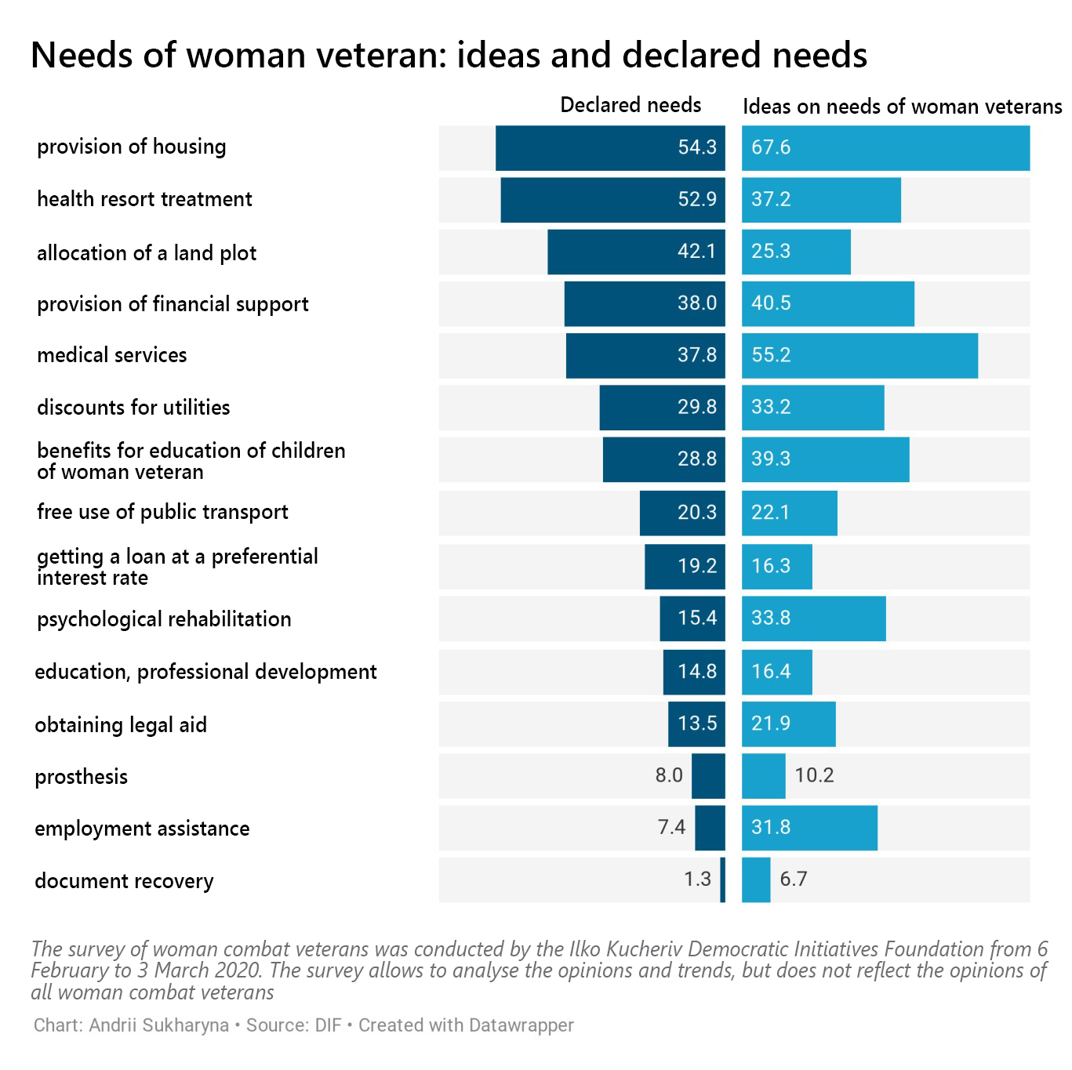
Social contacts
- Almost all woman veterans maintain their contacts with military colleagues even after returning. At the same time, a relatively large proportion of respondents (about a quarter) do not know any veteran NGOs.
- Even fewer respondents are members of veterans' organizations. In different groups, their number ranges from a quarter to a third of the number of the group. Herewith, cooperation with or membership in a veteran's organization is seen as an effective way to protect own rights and address current concerns. More than half of members of veteran NGOs said membership in NGOs helps them in their lives.
- Given the effectiveness of such organizations, the majority of respondents consider it advisable to involve them in providing social services.

Recommendations

- Compilation of a unified register of women veterans that will be accessible to all government agencies to simplify provision of benefits and services, since even veteran affairs specialist have no accurate data on the number of women veterans.
- National adaptation policies shall pay special attention to women veterans who recognize their life situation as being bad or even critical. The share of such veterans may reach 15% of the total number of those who returned from the JFO area. Their situation can be significantly improved by providing housing and permanent employment.
- Arranging regular medical examinations of military personnel in the JFO area will be of great importance to prevent the veterans' from having health problems. Gynaecologist offices and a sufficient number of doctors to serve woman service personnel should be provided at least in the major rear centres of the Armed Forces of Ukraine in Donbas (Mariupol, Bakhmut, Severodonetsk). This will allow timely prevention, diagnosis, first aid and first specialist care for those who are dismissed.
- Effective use of public funds provided for health care of female veterans requires introduction of targeted aid, which would allow them: to enjoy wellness practices (swimming pool, yoga, fitness), to plan annual sanatorium therapy, and to have advice and treatment from vertebrologists, neurologists and dentists.
- The available wellness and rehabilitation facilities for combatants shall be adapted to the real needs of the veteran community, including needs of female veterans.
- An important specific issue of assistance to veterans was raised in Lviv and Dnipro, namely the need for a special program to fund reproductive health care (artificial insemination). Identifying these needs on nationwide scale requires further research.
- Childcare benefits should be provided regardless of the number and age of children. For families with many children, the amount of aid should be greater, but not at the expense of those who have one child. In addition, rehabilitation assistance for women veterans should also include the costs of care and rehabilitation of their children.
- Psychological work with female veterans should be more systematic, starting as early as at the stage of service career and in the transition period. According to questionnaire survey, every second female veteran feels the need for psychological help. The issue should be addressed based on the involvement and appropriate professional training of women veterans themselves, as they acknowledge that the most effective psychological aid can be provided by specialists who have experience of work with ATO/JFO participants.

- Social adaptation and services for 3/4 of female veterans are unlikely to produce long lasting results, unless female veterans have their own (private or rented) housing. Accordingly, existing state housing programs should be reviewed first in order to resolve this problem within 5-7 years.
- Female veterans who lived before the war on the occupied territories must be guaranteed to receive from the state their own housing at the new place of residence.
- The system of professional retraining or career development for veterans should be aligned with the demand for workforce among employers in particular region. Thus, training of veterans would guarantee them a job at least for the first period

Appendices

І. Overall observations and conclusions by focus groups

According to the project requirements, focus groups were held in three cities: Lviv (28 January), Dnipro (31 January) and Mariupol (6 February). Each focus group was composed of 8-12 people with the assistance of local departments of the Ministry of Veterans Affairs, city centres for assistance to veterans, volunteer and veteran community associations.
In Lviv, the group consisted of 12 ATO/JFO female veterans from Lviv and the region. The Department of the Ministry of Veterans in Lviv region and the City Centre for Work with Veterans were engaged in the arrangements. In Dnipro, 8 veterans from Dnipro and the region took part in the focus group. A focus group of 12 veterans was held in Mariupol.
In all groups, the discussions followed the same guide in Russian and Ukrainian languages: each participant independently selected the language for the interview.
The moderator explained the participants that the research was carried out by a non-governmental organization called the Democratic Initiatives Foundation at the request of the East Europe Foundation within the preparation of a comprehensive program of psychological and mentoring support for veterans. Participants were informed the discussion during the focus group was audio reordered and the records will only be available for access only by a limited number of people, and only a report containing individual depersonalised statements of the respondents would be available to the general public.
Each discussion consisted of the introduction, the main part and the final part. The main part was divided into four blocks of questions: personal life circumstances of participants before and after the ATO/JFO, needs of women veterans, provision of social services to women veterans, public activity of veterans.
In addition, 10 in-depth interviews were conducted in three identified cities:
Lviv region:
- Volodymyr Shamray, Chief Specialist of the Department of the Ministry of Veterans Affairs, Temporarily Occupied Territories and Internally Displaced Persons in Lviv Region.
- Mariia Mediukh, ATO veteran, head of NGO Union of ATO Participants of Hnizdyzhiv Community.
- Svitlana Tkachuk, Director of Lviv Center for Provision of Services for Combat Veterans.
Dnipropetrovsk region:
- Nataliia Shulika, head of the City Department for ATO Participants Affairs, volunteer.
- Dariia Andrusenko-Yakotiuk, ATO/JFO veteran, volunteer.
- Oleksii Korzh, head of the Department of Veterans Affairs of the Regional State Administration of Dnipropetrovsk Region
Donetsk region:
- Olesia, psychological counsellor of the Mariupol City Center for Social Services for Families, Children and Youth, administrator of the ATO Participants Help Center.
- Yuliia Lypovetska, Head of NGO "Right4All", trainer psychologist at "All4One" project.
- Mariia Podybailo, head of the Novyi Mariupol volunteer NGO, ATO/JFO veteran.
- Anna Adam, head of the Department of the Ministry of Veterans Affairs in Donetsk Region.

General observation
The experience and memories of the war are still painful for most of the target group. At the same time, such feelings reinforce their perception of themselves as a separate group with their particular views, requirements and practices. For example, it is an advanced medical care and treatment of war injuries and illnesses.
Women veterans who are actively engaged in combining veterans' efforts to protect their rights are particularly keen to publicity and public approval and acknowledgement of such efforts.
At the same time, the participants acknowledge that an active women's veteran movement exists largely at the expense of grants, but organized veterans' communities are not divided by gender. Woman members of veteran communities and veteran NGOs emphasized that the state did not provide them with any financial or technical assistance. Therefore, they are on a constant search of sponsors and opportunities to receive grants for their activities. Participants from Lviv gave both good examples of general veteran organizations performance and the facts about pseudo-veteran organizations. But in Donetsk region, there is no information about the active engagement of female veterans in such organized movement.
Veterans have a growing concern that the state would begin to disengage from veterans and the veteran movement from 2019, and that the media would work to discredit the image of veterans and to form a negative attitude to them in the society.
The participants of the group noted that even active struggle for their rights and publicity had not yielded any practical and desired results. This leads not only to disappointment with their activities, but also to a loss of trust in the state.

Self-identification of veterans
Focus groups showed that there are several different categories of veterans:
- Veteran volunteers and volunteers who went to war through their own beliefs. They feel the worst, because the time revealed them a lot of proof that their sacrifice was senseless.
- Veterans who went to war because of life circumstances. There are two slightly different subcategories in this category: women who followed their men to the war and women who were military personnel before the war and were sent to the ATO/JFO area on a mission trip. The least critical yet the most constructive group in terms of proposals.
- Women seeking a personal career in the army in officer positions. They see veteran issues as a reflection of broader societal concerns and public sentiment toward the military.
- In-depth interviews highlighted another group of veterans - men and women who enlisted for a trip to the JFO area in 2017-2018 to receive the combat veteran status and financial aid from the state. Veterans of 2014-2019 do not recognize the right of this combat veteran category to join their community. Such women (and men) automatically fall into even greater social isolation.
Most women veterans emphasized that they had no particular social or legal problems unlike men. The experts are of the same opinion.
However, there is the other side of them being aware of their distinctiveness.
Firstly, women veterans noted that, in case of public declaration of their status (combat veteran) and appeal to their right to privileges, they would become an object of condemnation and hostility on the part of the majority of citizens who neither perceive the reason nor the content of such privileged status. Therefore, many veterans hesitate to declare their status.
Secondly, a biased attitude towards women dominates the army. The answers of the group participants suggest that health and gender issues were often used by the leadership to discharge women from military service. In addition, women veterans often did not receive well-deserved promotion because of the sexist attitude of the leadership of military units.

The attitude of the authorities to the problems of veterans through the eyes of women veterans
Women veterans note that the services provided to veterans largely depended on the attitude of the city (district, region) leadership. In particular, the city authorities provide better assistance to veterans registered in Dnipro, Lviv and Mariupol than the assistance received by veterans in the respective regions. At the same time, the attitude of the authorities to veterans in Kryvyi Rih and Donbas is extremely hostile.
Participants of the groups note the neglectful, superficial and hostile attitude of local authorities to their needs, corruption in institutions engaged in veterans' affairs.
Incompetence of Oschadbank employees responsible for payments to veterans was commonly mentioned. Benefit, housing or land allocation issues could be addressed promptly only through bribery of officials who, in turn, openly or indirectly demand bribe. It is about the regional state administrations, local social security departments and military registration and enlistment offices. This attitude of local officials was repeatedly mentioned in all three focus groups.

According to veterans, localises addressing of individual social assistance issues will have no result, since any practical decisions will be blocked because of shortcomings of the entire legal system governing the service in the army, army and ministerial bureaucracy and low moral and professional qualities of military commanders at all levels. The participants noted that good commanders are the exception, and surely there are no such commanders among the generals.

In health care, the following issues are most often raised:
- Preferential specialized medical services (such as dental prosthetics) for veterans are in fact of low quality and require inevitable extra payment in order to have quality assistance.
- According to the participants, state health resort treatment is provided with the worst quality, while the whole range of services is provided to people holding high positions and having connections, which further deepens the sense of injustice and discrimination among veterans.
- Participants of the group noted that psychological aid (including decompression) provided by the state and various non-state funds is most often provided formally and unprofessionally.

In employment and leisure:
- Most women have problems with finding a job or resuming their business after the service. In particular, employers do not benefit from 100% compensation for sick leaves, additional leaves for combat veterans.
- Banks are reluctant to grant loans to veterans. Veterans personally encountered such attitude.
- With regard to existing retraining courses and programs, participants express the concern that time and effort and new skills learned did not guarantee employment. While getting a job is the main motivation for participating in such programs and courses. In particular, when it came to advance training courses, participants complained that the classes were of formal nature, and it seemed that everything was done solely for the purpose of spending grant funds.
- The stories of veterans suggest that the most effective way to reintegrate to a peaceful life is to travel and find a new occupation which brings joy and enough income to feel comfortable in life.

Common problems:
Opinion of female veterans
- For veterans, especially those who are single and have children, there is an urgent problem with finding a job that can provide a sufficient income for the family and time to care about their kids' education, health and leisure.
- Employers are intolerant of female veterans who have active community life and ask for time off work from time to time.
- Like men, women veterans note the problem of alcohol addiction.
- Like men, women veterans have noticed a biased attitude (fear, dislike) to themselves when trying to get employed.
- Women veterans say that after the war, most marriages break up because of unresolved household issues.
- Veterans in eastern Ukraine have particularly keen issue of breaking the former circle of communication. ATO/JFO members are falling into social isolation, primarily because of widespread stereotypes about the causes of the war and different opinions as to the actions of the Ukrainian army, separatists and Russia.
Opinion of experts and representatives of the state engaged in provision of assistance to combat veterans:
- Most man and women veterans have problems because they are unable to find a decent job, maintain their family and receive quality medical care at the place of residence.
- Laws prescribing benefits for combat veterans, land plot allocation do not work because of their shortcomings, lack of accountability of officials for failure to implement them, due to lack of funds in local budgets.
- Most of the psychological problems of veterans derive from certain problems that a person had before the war.
- Counselling support system for veterans does not work on the whole.
- Veterans with children find it harder to find a job.
- Nominal dividing of veterans into men and women will only make the situation tougher, since basic needs and problems, except for gynecological care, are the same.

Illustrative quotes
Of course, I can tell a lot about the problems of military women. In general, it's very hard to have anything done. Regarding gender, I don’t know where it is. In my opinion, you can not find it anywhere. In words you will have everything, but in deed, you are nobody, you are nothing, you are rubbish. Thanks to the volunteers and those guys who are in Kryvyi Rih, and because I’m so sociable, I knock on all officials' doors trying to get an apartment, some aid for my kids, they just know me and I gave many interviews, but things aren't moving.
Military Medic, participant of ATO/JFO, volunteer, Kryvyi Rih

Well, there are no opportunities to fulfil oneself in the profession if you do not kiss *ss to decision-makers.
Participant of ATO/JFO, Dnipro

In my opinion, everything that we are doing now, unfortunately, especially in the situation which we experience now for the last six months, simply does not work. And honestly, probably one of the hardest psychological things is that I stopped believing that we can change something in this country, that nobody but yourself would care about you. Especially if you have some specific problems. And basically, I lost faith in this idea we all fought for. Because, what I see now, unfortunately, is totally different from why we went there. And, probably, now, having buried many of our close ones, current psychological state is tough. Because I don’t understand why we needed all that sacrifice if we go back to old things. The price is too big, many broken lives, and what we have in the end...
ATO/JFO female participant, volunteer, Dnipro

Now, I was clearly told by an official from the state administration, he told me - we will take a land plot on your name, but then we will right away buy it out. This is a common thing and it often happens. You will get a good land plot in Briukhovychi, but then they will give money right away. I say - no, I don't follow this scheme. And he tells me - you still won't get that land, you can only get it through us.
Participant of ATO/JFO, Lviv

Quotes from in-depth interviews:
During the work, I conclude for myself that for a man it is easier to attend career guidance than for a woman. The woman is more busy, because she has to fix her family, because if she had kids, the kids were with their grandmothers or separated. And she pays more attention to having the kids back in a family and get used to her again. And this is also a psychological problem. They cannot share this. They do not come immediately. And there is no trust. That is, until you start working with them, this trust does not come from nothing, they will not tell you about it... For a woman, it is harder to define her needs, because there are more of them. She comes back, she stops caring about how she looks. This often causes a collapse of the family. If there was a relationship, it changes 180 degrees. Because they speak different languages. And they become closer with their buddies, they have more common things to talk about. Everything changes. She says: “My manner of walking has changed. The way I walk is totally different. I have even forgotten how I combed my hair, and now my husband tells me this... ” It is the husband who notes that I now have very little of a woman in me. Therefore, it is very important to form psychological rehabilitation groups so that to engage not only counsellors, 'cause if you say there is a psychological counsellor, nobody will come there. That is, it should be just a group for women that will cover their concerns. Very many were engaged in handicraft. Many can cook. They need to bring that woman back in them. And this group should be arranged on Saturdays. Many of them have little kids. So that they could take their kids with them. Look after their kids. Only women. And arrange some fun workshops for the kids. So that it could contribute to development of families and make them stronger. Have some contests. Not competitive, but sport tracks, to travel somewhere. They need to get closer. They would feel interesting with each other, have common things to talk about, but those must be joint activities with regular people. They need social adaptation. We tried to do this within our Beauty Academy club, what I told you about. We invite both, so there is no difference. Just nobody puts focus to that, then the balance comes. When they see real life examples, and when they begin to interact, this brings them back.
Yuliia Lypovetska, Head of NGO "Right4All", trainer psychologist at "All4One" project

In my opinion, it is necessary to divide in terms of psychological rehabilitation. That is, women still need some separate program, because a woman, after returning from war or returning from a contract service, is, apart from other things, a mother. She faces condemnation of the society: why did you go, are you a man? That is, in terms of psychological rehabilitation and such decompensation, I believe there should be a separate. program. They need what men need as well, but women need some special program, I believe...
Emphasis should be placed on the fact that women take part in hostilities, they return, and women are also veterans. And there should be social advertising. There were those videos "Thanks to You," "We thank the Veterans". They featured only guys, but they could also feature women as well. And to distribute it to changes that public condemnation. Because many do not understand why you went there.
Anna Adam, head of the Department of the Ministry of Veterans Affairs in Donetsk Region.

In fact, in general, the state does not really manage specifically female veteran issues. They manage veteran issues in general, without detailing, without regard to gender. Basically, there is nothing like that at all. In view of the rather large number of female veterans on a nationwide scale, perhaps, the time to split these issues has come. I recognise that I imagine this situation when a woman veteran really wants to be treated somewhere. And they can't find a separate ward for her. They will not provide her with a separate ward and there is no special ward for women. And this is actually the case. In fact, the issue of women veterans is not monitored separately. They are considered together with the rest of the issues. As I have said before, the rest of the issues is 90 percent of men issues, and the issues of women veterans are addressed somewhere locally in extreme situations, when a person is really seeking help specifically for her. That is, in fact, as far as I know, there is no such specific area as a counsellor for women's problems. I'm sure there are such problems. But I don't see it, I don't observe it. I have never heard that there are any ways and areas to deal with this issue. There is medical sector that has to handle these women's problems for free. Because these are not the conditions for women anyway. Let's say it's not zero, let 's say it's just somewhere in the training field, but still these are not conditions for women and for women's health. Therefore, this issue needs to be addressed systematically. We have it locally everywhere.
Svitlana Tkachuk, Director of Lviv Center for Provision of Services for Combat Veterans.

What I do know is that there are health problems. And I think they are different from men, because the first function of women is motherhood. And there are problems with getting pregnant. I don't know if they are psychosomatic or... Let the doctors deal with this. And I do not know whether there is proper therapy or not. We have a veterans rehabilitation department. That is, everyone who has already been demobilized, has the combat veteran status can come to us for rehabilitation at the veterans hospital. There is a separate office for ATO participants only. And there is only one room for women. With two beds. And we understand: if the treatment takes 18 days, how many women can undergo this rehabilitation there during a year? Very few. And we can also place the mother or the wife of the deceased into this ward. So this is absolutely not enough. And what about their kids. That is, they come back, and what I have also heard was: I can't get a good job because I have a child. I haven's seen my kid for so long, haven't looked after him or her. And now I won't be able to… for example, she would like to work half a day, so that to spend more time with her kid. And as I understand, the employment situation is not good at all. And those girls who came today, I know that they are trying to work for themselves, not for someone else, to have a more flexible schedule. And girls who did not come to us from Pavlohrad, I understand that they do not work at all, because, first of all, their health condition does not allow them to. They have disabilities and so on. And again, they want to spend more time with their kids which they lacked when their mum was in ATO. And again, we get back to psychological concerns. And I understand that if such woman attended a counsellor, or even a psychotherapist, she might have looked at the situation differently. But our experience suggests that we do not have such a culture of seeking counsellor's assistance. And some of the women say I'd rather have some wine or something like that, and it will make me feel easier.
Nataliia Shulika, Dnipro, head of City Department for ATO Participants Affairs, volunteer

ІІ. Technical report of the group survey carried out for ATO/JFO woman combatant veterans
The survey of woman combatant veterans was conducted by the Ilko Kucheriv Democratic Initiatives Foundation at the request of the East Europe Foundation. The survey was conducted between 6 February and 3 March 2020. A total of 763 questionnaires were collected, of which 527 respondents had already returned from the JFO area.
The survey helps to identify and analyse the trends of opinions of woman combatant veterans, but its results can not be generalised for the entire veteran community.
Some questions highlighted the differences between the respondents who are now outside Donetsk and Luhansk regions - that is, those who have already left the conflict zone and returned to a peaceful life.

SURVEY FINDINGS

1. How long ago you have returned from the war?
 | Of all,  (N = 763),% | Without Donbas,  (N = 314)%
1 - 1-5 months ago | 9.2 | 10.8
2 - 6 months to a year | 8.9 | 17.2
3 - a year to 2 years | 15.3 | 25.8
4 - 2 to 3 years | 11.9 | 18.2
5 - 3 to 4 years | 10.2 | 14.0
6 - over 4 years ago | 13.5 | 10.2
I am (serve / work) in the JFO area | 30.9 | 3.8

2. How is your life generally going after you are back home? How would you generally describe your life situation?
 | Number of responses, (N = 527),% | Without Donbas,  (N = 302), %
1 - the situation is generally good, without serious problems | 35.1 | 29.8
2 - the situation is generally good, but there are some problems | 42.7 | 47.4
3 - the situation is bad, there are many problems | 13.1 | 15.6
4 - the situation is not good at all, it is critical | 1.5 | 1.3
5 - hard to say/no answer | 7.6 | 6.0

3. If you think your situation is not good, in what areas do you have difficulties? (more that one answer is possible)
 | Generally bad situation (N = 117), % | Without Donbas,  (N = 69), %
1 - difficulties with employment | 27.4 | 37.7
2 - with housing | 55.6 | 55.1
3 - health problems | 50.4 | 65.2
4 - with financial support | 40.2 | 34.8
4 - in relationships with the family and relatives | 27.4 | 39.1
5 - in relations with the people around me, other people | 20.5 | 27.5
6 - loss of the sense of life, depressed mood | 10.3 | 15.9
7 - other (specify) | 3.4 | 5.8

4. What is your current situation with employment?
 | Number of responses, (N = 527), % | Without Donbas,  (N = 302), %
1 - I work in the same place as before | 69.6 | 59.3
2 - I have changed the job for a better one | 8.0 | 8.3
3 - I have other job, worse than before | 4.2 | 5.0
4 - I do not have a permanent job at all because I can not get a job | 5.1 | 8.3
5 - I can not work for objective reasons (baby, family, health, etc.) | 8.5 | 12.3
6 - other (specify) | 2.1 | 3.6
I serve in the Armed Forces/Police | 3.6 | 3.0
No answer | 0.6 | 0.3

5. Did you have any difficulties in getting a job after returning from the front line?
 | Number of responses,  (N = 527), % | Without Donbas,  (N = 302), % | Without Donbas and those currently in military service  (N = 139), %
1 - there were no difficulties | 62.4 | 54.6 | 31.7
2 - there were some difficulties, but everything has settled | 15.4 | 16.9 | 25.9
3 - there were serious difficulties, I had to get a job other then I wanted | 4.0 | 5.6 | 11.5
4 - I couldn't find a job | 6.8 | 10.6 | 21.6
No answer | 11.4 | 12.3 | 9.4

6. Do you think being an ATO veteran affected your employment?
 | Among those who have returned  (N = 527),% | Without Donbas,  (N = 302), % | Among those who have returned and are not in service  (N = 289), % | Among those who have returned and are not in service (without Donbas)  (N = 132), %
1 - generally, it did not affect | 48.8 | 40.7 | 48.8 | 35.6
2 - yes, positively, they wanted to help me | 9.7 | 10.6 | 10.4 | 13.6
3 - yes, negatively, I was prejudiced | 4.2 | 7.0 | 6.2 | 12.1
4 - hard to say/no answer | 37.4 | 41.7 | 34.6 | 38.6

7. Did you seek help when getting a job? More than one answer is possible
 | Among those who have returned  (N = 527),% | Without Donbas,  (N = 302), %
1 - no, there was no need for that | 66.4 | 58.3
2 - yes, with the state employment service | 7.2 | 10.6
3 - yes, with other state organizations | 3.2 | 4.3
4 - with veteran NGOs | 3.0 | 5.3
5 - with relatives, acquaintances | 9.9 | 13.2
6 - other (specify) | 1.1 | 1.7

8. Did they help you?
Number of mentions from those who sought help
(N = 101),%
1 - yes, they helped | 29.7
2 - they did not help, but they tried | 53.5
3 - they did not even try to help | 9.9
No answer | 6.9

9. Do you currently feel any need in respect of your job?
 | Of all,  (N = 763),% | Of those who have returned (N = 527),%
1 - no, generally, I am satisfied with my job | 61.3 | 58.4
2 - I want to work in my speciality | 5.0 | 6.1
3 - I want to learn a new profession | 9.3 | 10.8
4 - I want to start my own business | 13.1 | 15.6
5 - other (specify) | 1.6 | 1.5
No answer | 9.7 | 7.6

10. What help do you need to implement your plans?
 | Of all,  (N = 763),% | Of those who are not satisfied with their job  (N = 295), %
1 - help get a job in my speciality | 5.2 | 9.2
2 - to enrol to an educational institution | 7.9 | 10.8
3 - to attend retraining courses | 8.9 | 15.3
4 - to learn to run a business | 14.8 | 27.1
5 - get a loan to start my own business | 9.8 | 20.0
6 - just to get monthly aid as an ATO veteran | 39.4 | 26.4
7 - other (specify) | 0.9 | 2.0
Be provided with housing | 0.8 | 0.3
I do not need help | 2.8 | 1.4

11. Would you like to start or continue your military career?
 | Of all,  (N = 763),% | Of those who have returned (N = 527),%
1 - yes | 43.5 | 48.2
2 - no | 25.7 | 26.2
3 - hard to say/no answer | 30.8 | 25.6

12. If yes, would you like to get special military education?
 | Number of responses, (N = 332),%
1 - yes | 52.1
2 - no | 14.8
3 - I already have such education | 31.3
No answer | 1.8

Now, let's move on to health care issues

13. Have you had any health issues related to your ATO service? More than one answer is possible
 | Of all,  (N = 763),% | Of those who have returned (N = 527),%
1 - no, there were no significant issues | 54.4 | 51.2
2 - I have a disability | 2.4 | 3.2
3 - I have been wounded | 1.3 | 1.9
4 - Now I suffer a serious chronic condition | 11.7 | 12.0
5 - The diseases I suffered before got worse | 26.0 | 29.8
6 - I had an intense psychological distress | 19.1 | 20.5
7 - other (specify) | 0.3 | 0.2

14. Do you need any medical care?
 | Of all,  (N = 763),% | Of those who have returned (N = 527),%
1 - no, I do not need it | 34.6 | 33.6
2 - in general, it would be good to have it | 48.4 | 49.3
3 - it is very much needed | 8.9 | 10.1
4 - it is one of my pressing needs | 5.2 | 5.3
No answer | 2.9 | 1.7

15. What kind of health care do you feel you need first and foremost? (More than one answer is possible)
 | Of all,  (N = 763),% | Except for those who do not need  (N = 499),%
1 - in-patient treatment | 9.4 | 13.0
2 - surgery | 3.7 | 5.4
3 - outpatient treatment by specialists | 13.0 | 19.0
4 - health resort treatment | 48.8 | 61.1
5 - psychological counsellor advice | 11.9 | 16.8
6 - money to buy necessary medicines | 13.0 | 18.4
7 - surgery or treatment abroad | 1.6 | 2.4
8 - possibility to have health improving activities (swimming pool, yoga, fitness, etc.) | 53.1 | 56.9
9 - other (specify) | 0.8 | 1.2

16. What doctors do you need first and foremost? (More than one answer is possible)
 | Except for those who do not need (N = 499),% | Those who are in sore need of them (N = 108),%
1 - general practitioner | 21.8 | 21.3
2 - surgeon | 10.2 | 17.6
3 - prosthetist | 5.0 | 5.6
4 - dentist | 31.9 | 36.1
5 - gynecologist | 28.5 | 36.1
6 - gastroenterologist | 20.0 | 21.3
7 - vertebrologist (back and joints) | 40.5 | 50.9
8 - neurologist | 31.7 | 40.7
9 – psychologist | 17.4 | 27.8
10 - dermatologist | 9.4 | 9.3
11 - cosmetologist | 14.8 | 15.7
12 - other (specify) | 2.0 | 5.6

17. Have you sought medical care after returning from the war?
 | Among those who have returned  (N = 527),% | Without Donbas,  (N = 302), %
1 - yes, regularly | 12.1 | 17.5
2 -sometimes | 55.4 | 61.3
3 - never | 30.2 | 20.5
No answer | 2.3 | 0.7

18. If you sought medical care, how would you rate the quality of those services?
 | Of those who have sought (N = 356),%
1 - rather positive | 13.5
2 - mostly positive | 61.2
3 - mostly negative | 21.9
4 - rather negative | 2.8
No answer | 0.6

19. If you rated the quality of the medical services received as negative, why? (More than one answer is possible)
Of those who have rated as negative
(N = 90),%
1 - I had to pay for services that are supposed to be free | 42.2
2 - The doctors showed no commitment, did not try to help me | 28.9
3 - I was not satisfied with competence of those doctors | 52.2
4 - It took ages to have an appointment with the doctor | 16.7
5 - The medicines were too expensive | 25.6
6 - There is no necessary medical facility at my place of residence, so it took long way to get there | 14.4
7 - other (specify) | 1.1

20. Have you experienced any psychological difficulties in communicating with others after returning from the front line?
 | of those who have returned (N = 527),% | Without Donbas,  (N = 302), %
1 - yes, and quite often | 12.7 | 18.2
2 - sometimes | 34.7 | 42.7
3 - never | 49.5 | 37.4
No answer | 3.0 | 1.7

21. If you had any difficulties in communicating with other people (friends, family, relatives, acquaintances), please specify, which ones?
Of those who have had difficulties
(N = 250),%
1 - people do not understanding of my life stance, my values | 43.6
2 - biased attitude towards me | 8.4
3 - my asociality, unwillingness to discuss my problems with other people | 24.8
4 - my too emotional reactions to what is happening | 36.4
5 - other (specify) | 1.6

22. Do you think it advisable to seek psychological advice for psychological adaptation?
Of those who have had difficulties
(N = 250),%
1 - yes, and I have already done it | 27.2
2 - yes, maybe it is worth doing  move to question 25 | 44.0
3 - no, I don't think a psychologist can help  move to question 25 | 20.0
No answer | 8.8

23. If you have sought help from a psychological counsellor, did you get the help you needed?
Among those who have sought
(N = 68),%
1 - yes, absolutely | 32.4
2 - yes, partially | 47.1
3 - not at all | 14.7
No answer | 5.9

24. If you are not satisfied with your counselling why?
Among those who did not receive comprehensive help
(N = 46),%
1 - he (she) was obviously not competent enough | 6.5
2 - he (she) may have been competent, but he (she) is not aware of our problems | 34.8
3 - he (she) was clearly indifferent to me and my problems | 6.5
4 - I have realised that the causes of my problems are not psychological, but then rather relate to life circumstances | 23.9
5 - other (specify) | 6.5
No answer | 21.7

25. What do you think should be the psychological aid for veterans?
(mark whatever you deem fit)
Of all,
(N = 763),%
1 - these should be groups, separately for men and separately for women | 10.7
2 - it should be individual consultations rather than groups | 41.2
3 - Specialists who have been in the front line and know what how does it feel being there should counsel veterans | 42.7
4 - other (specify) | 1.3

Now let's talk about your living conditions

26. What are your current living conditions?
 | Of those who have returned (N = 527),% | Without Donbas,  (N = 302), %
1 - we (I) have our (my) own housing | 29.0 | 24.8
2 - we (I) live with our (my) parents or relatives | 21.3 | 23.2
3 - I live in a hostel | 5.3 | 8.3
4 - we (I) rent housing | 37.8 | 34.8
5 - other (specify) | 1.1 | 1.3
No answer | 5.5 | 7.6

27. Do you need any improvement of your living conditions?
 | Of those who have returned (N = 527),% | Without Donbas,  (N = 302), %
1 - yes, because I have nowhere to live | 25.6 | 23.8
2 - yes, I need to improve my living conditions | 47.2 | 50.3
3 - no, I do not need it | 20.9 | 17.9
No answer | 6.3 | 7.9

28. Have you applied to state authorities to improve your living conditions?
 | Among those who have returned  (N = 527),% | Among those who have returned and reported the need  (N = 384),%
1 - no, I do not need it | 20.7 | 4.9
2 - yes, I have applied and I have been provided with housing | 2.3 | 2.1
3 - I have applied and have been placed on the waiting list | 23.1 | 31.3
4 - I have applied but have been refused | 10.8 | 14.8
5 - I have not applied, although there is a need, but I do not believe that the government will help me | 31.9 | 41.7
6 - other (specify) | 2.5 | 2.9
No answer | 8.7 | 2.3

29. Do you know about social services and benefits to which you are entitled as an ATO veteran?
 | Of all,  (N = 763),% | Of those who have returned (N = 527),%
1 - yes, I am well aware of them | 29.4 | 27.3
2 - I know something about that, but not everything | 61.6 | 63.8
3 - I know almost nothing | 6.9 | 7.8
No answer | 2.1 | 1.1

30. Do you know where and whom to apply to get aid you need?
 | Of all,  (N = 763),% | Of those who have returned (N = 527),%
1 - yes, I know | 23.2 | 22.0
2 - I know about some types of aid, but not all of them | 60.3 | 62.4
3 - I know almost nothing | 14.3 | 14.0
No answer | 2.2 | 1.5

31. Have you applied to relevant state authorities for specific services or aid? (separately to those who know where to apply)
 | Of those who have returned (N = 527),%
1 - yes, I apply regularly | 11.6
2 - I apply sometimes | 60.2
3 - I have never applied | 26.6
No answer | 1.7

32. Have you applied for aid to non-governmental bodies, if yes, to which ones? More than one answer is possible
of those who have returned,
(N=527),
%
1 - to veteran NGOs | 16.3
2 - to other NGOs | 11.0
3 - to international foundations | 3.0
4 - to the media | 3.4
5 - to friends, acquaintances | 30.0
6 - other (specify) | 10.2

33. Which of the below problems do you feel you need to address?
More than one answer is possible
of those who have returned,
(N=527), %
1 - employment assistance | 7.4
2 - education, professional development | 14.8
3 - provision of housing | 54.3
4 - repair of the house or apartment | 17.6
4 - health care services | 37.8
5 - health resort treatment | 52.9
6 - prosthetics | 8.0
7 - psychological rehabilitation | 15.4
8 - allocation of a land plot | 42.1
9 - provision of financial support | 38.0
10 - getting a loan at a preferential interest rate | 19.2
11 - document recovery | 1.3
12 - obtaining legal advise | 13.5
13 - utility discounts | 29.8
14 - free use of public transport | 20.3
15 - education benefits for women veterans' dependants | 28.8
16 - other (specify) | 0.8

34. Which of those needs have been sought? More than one answer is possible
of those who have returned,
(N=527),
%
1 - employment assistance | 7.4
2 - education, professional development | 8.7
3 - provision of housing | 30.7
4 - repair of the house or apartment | 5.1
4 - health care services | 23.0
5 - health resort treatment | 22.0
6 - prosthetics | 2.8
7 - psychological rehabilitation | 8.0
8 - allocation of a land plot | 35.9
9 - provision of financial support | 22.6
10 - getting a loan at a preferential interest rate | 6.1
11 - document recovery | 1.3
12 - obtaining legal advise | 5.7
13 - utility discounts | 42.5
14 - free use of public transport | 26.9
15 - education benefits for women veterans' dependants | 8.7
16 - other (specify) | 1.3

35. Which of those problems have been addressed with positive result?
of those who have returned,
(N=527),
%
1 - employment assistance | 1.7
2 - education, professional development | 4.7
3 - provision of housing | 2.7
4 - health care services | 11.0
5 - health resort treatment | 9.3
6 - prosthetics | 2.1
7 - psychological rehabilitation | 3.6
8 - allocation of a land plot | 13.3
9 - provision of financial support | 10.6
10 - getting a loan at a preferential interest rate | 2.3
11 - document recovery | 0.8
12 - obtaining legal advise | 1.7
13 - utility discounts | 39.5
14 - free use of public transport | 32.1
15 - education benefits for women veterans' dependants | 4.6
16 - other (specify) | 0.4
none | 3.4

33-35. Analysis of the success in addressing problems

 | There is a problem | Attempted to address it, % | Successfully addressed, %
1 - employment assistance | 8.3 | 92.3 | 13.9
2 - education, professional development | 13.6 | 65.6 | 23.8
3 - provision of housing | 54.8 | 57.8 | 3.4
4 - health care services | 39.1 | 60.9 | 25.0
5 - health resort treatment | 53.3 | 42.6 | 23.4
6 - prosthetics | 7.7 | 36.1 | 61.5
7 - psychological rehabilitation | 15.3 | 54.2 | 15.4
8 - allocation of a land plot | 42.9 | 84.2 | 19.4
9 - provision of financial support | 39.5 | 58.1 | 25.9
10 - getting a loan at a preferential interest rate | 19.5 | 32.6 | 13.3
11 - document recovery | 1.5 | 100.0 | 14.3
12 - obtaining legal advise | 12.5 | 44.1 | 23.1
13 - utility discounts | 30.4 | 144.8 | 80.7
14 - free use of public transport | 21.0 | 131.3 | 83.8
15 - education benefits for women veterans' dependants | 29.3 | 26.8 | 32.4
16 - other (specify)

36. If we talk not only about your needs, but the needs of ATO veterans in general, what do you think are the priority areas? (more that one answer)
Of all,
(N = 763),%
1 - employment assistance | 31.8
2 - education, professional development | 16.4
3 - provision of housing | 67.6
4 - health care services | 55.2
5 - health resort treatment | 37.2
6 - prosthetics | 10.2
7 - psychological rehabilitation | 33.8
8 - allocation of a land plot | 25.3
9 - provision of financial support | 40.5
10 - getting a loan at a preferential interest rate | 16.3
11 - document recovery | 6.7
12 - obtaining legal advise | 21.9
13 - utility discounts | 33.2
14 - free use of public transport | 22.1
15 - education benefits for women veterans' dependants | 39.3
16 - other (specify) | 1.3

37. What do you think should be improved in providing services to women like you? More than one answer is possible
 | Of all,  (N = 763),% | of those who have returned (N = 527),%
1 - Provide more information so that ATO women veterans know exactly what they are entitled to | 59.6 | 61.5
2 - To reduce bureaucracy and red tape in state authorities where women are required to provide a large number of certificates | 57.0 | 54.6
3 - There should be a "hotline" where one can complain about poor performance of a state agency | 31.5 | 32.3
4 - In general, wider publicity is needed for the problems of ATO veterans | 36.0 | 38.7
5 - other (specify) | 0.4 | 0.2

38. Do you keep in touch with your sworn brother from the war?
 | of those who have returned  (N=527), % | Without Donbas,  (N = 302), %
1 - yes | 86.1 | 93.0
2 - no | 8.0 | 4.0
Other | 1.1 | 1.3
No answer | 4.7 | 1.7

39. Do you know ATO veterans organizations?
 | of those who have returned,  (N=527), % | Without Donbas,  (N = 302), %
1 - yes | 55.4 | 71.2
2 - no | 40.2 | 26.2
Other | 0.8 | 1.3
No answer | 3.6 | 1.3

40. Are you a member of such an organization?
 | of those who have returned,  (N=527), % | Without Donbas,  (N = 302), %
1 - yes | 24.1 | 33.4
2 - no | 70.8 | 62.9
Other | 0.8 | 1.3
No answer | 4.4 | 2.3

41. If yes, does your membership or collaboration with a veterans organization help you address your life problems?
 | Among members of veterans organizations (N = 127),%
1 - yes | 51.2
2 - no | 37.8
Other | 9.4
No answer | 1.6

42. Do you think it is appropriate to engage veterans organizations in the provision of services to ATO veterans?
 | of all, (N = 763),% | Among members of veterans organizations (N = 127),%
1 - yes | 65.7 | 77.2
2 - no | 5.5 | 5.5
3 - hard to say/no answer | 28.8 | 17.3

SOCIAL AND DEMOGRAPHIC PROFILE
43. Your age
 | of all,  (N = 763) | of all,%
18-29 | 204 | 26.7
30-39 | 322 | 42.2
40-49 | 206 | 27.0
50+ | 31 | 4.1

44. Education
 | of all,  (N = 763) | of all,%
1 - incomplete secondary | 5 | 0.7
2 - general secondary | 19 | 2.5
3 - vocational secondary | 116 | 15.2
4 - incomplete higher | 56 | 7.3
5 higher | 567 | 74.3

45. Your marital status
 | of all,  (N = 763) | of all,%
1 - married | 377 | 49.4
2 - I am not officially married, I have a live-in relationship | 80 | 10.5
3 - divorced | 185 | 24.2
4 - I am not and has not been married | 121 | 15.9

46. Do you have children?
 | of all,  (N = 763) | of all,%
1 - yes, one child | 349 | 45.7
2 - two children | 162 | 21.2
3 - three children | 25 | 3.3
4 - four or more | 8 | 1.0
5 - I have no children | 219 | 28.7

47. If you have children, what age are they?
 | Of those who have children  (N = 544),% | of all,%
1 - preschool | 143 | 26.3
2 - elementary school children (under 13) | 176 | 32.4
3 - teenagers (13-17) | 89 | 16.4
4 - 18 and above | 131 | 24.1
No answer | 5 | 0.9

48. How would you rate your financial situation?

 | of all,  (N = 763) | of all,%
We hardly make ends meet, there is not enough money even for the essentials | 46 | 6.0
There is enough money to buy food and inexpensive essentials | 255 | 33.4
In general, we make enough money for life, but buying long use items such as furniture, fridge, TV is difficult | 355 | 46.5
We have a good financial condition, but we can not yet afford certain things (buying an apartment, car, etc.) | 79 | 10.4
We can afford nearly anything we want | 4 | 0.5
Hard to answer | 24 | 3.1

49. What is your job?
 | of all,  (N = 763) | of all,%
1 - in military service | 258 | 33.8
2 - in the public sector (budgetary sector employees - teachers, doctors, etc.) | 80 | 10.5
3 - in the private sector | 13 | 1.7
4 - I own a business | 1 | 0.1
5 - in an NGO | 8 | 1.0
6 - in a state agency | 183 | 24.0
7 - engaged in the agriculture | 4 | 0.5
8 - actually unemployed | 37 | 4.8
9 - temporarily unemployed now because I am on a maternity leave, etc. | 32 | 4.2
National Police | 90 | 11.8
10 - other (specify) | 5 | 0.7
No answer | 49 | 6.4

50. Where do you live (settlement)?
 | Of all,  (N = 763) | Of all, % | Number of answers, without Donbas,%
Vinnytsia | 20 | 2.6 | 6.4
Volyn | 4 | 0.5 | 1.3
Dnipropetrovsk | 19 | 2.5 | 6.1
Donetsk | 445 | 58.3 | -//-
Zhytomyr | 49 | 6.4 | 15.6
Zaporizhzhia | 3 | 0.4 | 1.0
Kyiv | 28 | 3.7 | 8.9
Kirovohrad | 2 | 0.3 | 0.6
Luhansk | 4 | 0.5 | 1.3
Lviv | 38 | 5.0 | 12.1
Mykolaiv | 16 | 2.1 | 5.1
Odesa | 2 | 0.3 | 0.6
Poltava | 5 | 0.7 | 1.6
Sumy | 34 | 4.5 | 10.8
Ternopil | 17 | 2.2 | 5.4
Kharkiv | 27 | 3.5 | 8.6
Kherson | 1 | 0.1 | 0.3
Khmelnytskyi | 14 | 1.8 | 4.5
Cherkasy | 17 | 2.2 | 5.4
Chernivtsi | 14 | 1.8 | 4.5
Chernihiv | 2 | 0.3 | 0.6
No data | 2 | 0.3 | 0.6

51. Did you live in the same town (village) where you are now before the war?
 | Of all, (N = 763) | Of all, %
1 - yes, I lived in the same town (village) | 516 | 67.6
2 - I moved from another region of Ukraine | 67 | 8.8
3 - I moved from the occupied part of Donbas | 160 | 21.0
4 - I moved from Crimea | 7 | 0.9
5 - other (specify) | 13 | 1.7

