Methodology
The Ilko Kucheriv Democratic Initiatives Foundation, together with the Centre for Political Sociology, conducted a face-to-face survey among internally displaced persons (IDPs) from 19 February to 1 March 2023. 1,202 adult respondents were interviewed in Kyiv, Dnipro, Odesa, Lviv, Uzhhorod and Ternopil (200 people in each city). The sample of the poll is random, with maximum coverage of respondents in different places of residence - housing sector, places of centralized resettlement (g government agencies, dormitories, schools, kindergartens, offices), shelters, IDPs support centres, etc. The random error does not exceed 3%.
Data from a poll conducted by the Ilko Kucheriv Democratic Initiatives Foundation in cooperation with the Centre for Political Sociology from 27 March to 5 April 2022 were used for comparative and context analysis. The sample consisted of 1,000 adult IDPs interviewed in Zakarpattia, Ivano-Frankivsk, Lviv, Ternopil, and Chernivtsi regions (200 respondents in each region).
All conclusions and recommendations refer to IDPs living in Kyiv, Dnipro, Odesa, Lviv, Uzhhorod and Ternopil at the time of the poll.

Conclusions
It is highly likely that most of the people who had evacuated from Chernihiv, Sumy, Kyiv region and city of Kyiv and settled in the western regions in spring 2022, returned to their home communities. Our observations independently confirm relevant data of the survey conducted by the International Organisation for Migration (IOM).
At the same time, we see the growing number of IDPs from Kherson region in comparison to spring 2022. Despite the de-occupation of the right bank Kherson region, it is highly likely that people will not return until the end of war or/and an effective ceasefire. Moreover, the liberation of Kherson areas allowed many people to leave the region for safer places, mostly in Odesa.
IDPs from the occupied communities are trying to move to safer urban communities, economic and transport hubs close to their home regions. IDPs from the Donetsk region are trying to settle in Dnipro, while IDPs from Kherson and Mykolaiv regions are trying to settle in Odesa.
Meanwhile, we observe a decrease in IDPs movement to the west of the country. This is confirmed by results of the IOM poll. However, the western direction is still popular among the IDPs who evacuated from the Sumy, Chernihiv, Kharkiv regions de-occupied in 2022. It reveals how slow is early reconstruction of the destroyed houses and social infrastructure of the de- occupied regions and demonstrates a high level of anxiety among the IDPs regarding possible Russian hostile actions.
Success of the Ukrainian defence forces on the battlefield has been a major factor, which persuaded many IDPs to stay in Ukraine. After 12 months of the war, fewer IDPs are looking to move to the regions which border the EU and provide opportunity for quick emigration in case of a major crisis.
Poverty among the IDPs has increased since April 2022. After 12 months of war, 51% of IDPs live in poverty and 33% are below the poverty line, a stark contrast to April 2022 when only 19% said they did not have enough money even to buy food regularly. The poorest IDPs live in Odesa and Kyiv.
Most IDPs said they need cash grants, food, free medicines, free medical care, shelter and household chemicals. Medicines, free medical care, cash payments and employment assistance are in deficit. Meanwhile, provision of household chemicals, food, clothing, personal hygiene items and assistance in accessing administrative services are abundant.
- Need for permanent housing is urgent for IDPs who settled in Uzhhorod (59%), Odesa (47%) and Kyiv (39%). This issue is especially important for people who evacuated from Kherson (45%), Luhansk (44%), Sumy (42%) and Zaporizhzhia (39%) regions.
- Need for free and affordable medical aid and examination is the most acute for IDPs in Odesa (68%), Ternopil (45%), Uzhhorod (42%) and Lviv (40%). This is especially urgent for the senior citizens aged 50-59 years (51%) and 60+ years (70%) from Kherson, Mykolaiv and Donetsk regions.
- Need for free medicines is highly urgent for IDPs who live in Odesa (68%), Lviv (44%), Kyiv (39%) and Uzhhorod (36%). Again, most of these 50+ years old IDPs came from Kherson, Mykolaiv, Sumy, Chernihiv, Donetsk and Luhansk regions.
- Employment assistance is wanted by 43% of IDPs who settled in Odesa, 37% of IDPs who live in Uzhhorod and 29% of IDPs in Ternopil.
- Need for psychological assistance is required for IDPs in Uzhhorod (40%).
Dependence on humanitarian aid is increasing among IDPs. 38% of IDPs admitted that they urgently need humanitarian aid. More IDPs need money, food, household and personal hygiene items, medicines and medical care. The most critical situation with dependence on humanitarian aid is observed among the IDPs who settled in Odesa (67%), Uzhhorod (49%) and Kyiv (37%).
Significant deterioration of the IDPs wellbeing happened due to the loss of financial savings and high unemployment rate. In February 2023, only 29% of IDPs admitted that they had savings, a huge decline from 76% in April 2022. We argue that in April 2023 this number will fall to 18%.
The likelihood of improvement is extremely low, since 69% of IDPs are unemployed including 37% who can work. Women are especially vulnerable, 42% of female respondents can work but they are unemployed. The hardest situation is among young women aged 18-29. Situation with unemployment of IDPs is of concern in Odesa (53%), Dnipro (46%) and Ternopil (40%).
In general, IDPs assess performance of humanitarian organisations as good. At the same time, IDPs reported that necessary aid is often insufficient. Survey also showed that in some cases humanitarian organisations do not address most urgent needs.
The most frequently mentioned local organisations, aid providers to IDPs, are:
- Dnipro: Bakhmutska diaspora (Бахмутська діаспора), Nasha Sprava Ukraina (Наша справа Україна), BF Pomagayem (БФ Помагаєм)
- Odesa: Hostynna hata (Гостинна хата).
There is a great sense of uncertainty among the IDPs regarding their housing conditions in the near future. 16% of IDPs fear losing their temporary homes or shelters by May 2023. Overall, 44% of IDPs are afraid to become homeless by the end of 2023. We argue that these sentiments may be a result of their living conditions. Most IDPs live in temporary or rented accommodation and many people are confused about their future. This issue can become especially acute in Dnipro and Odesa where many IDPs rent flats or houses and may run out of money to pay rent at the end of the year.
The majority (65%) of IDPs have a positive view of their integration into the host community, but there is reason to believe that people perceive their involvement in community life to be higher than it actually is. This is based on the results of a survey conducted by the DIF in December-February 2023.
The length of time spent in the host community has a positive impact on involvement of IDPs in volunteer activities. The IDPs who moved to the host communities at the beginning of the full-scale invasion were able to organise their lives more or less over the course of a year.
After 12 months of war, we observed a growing number of IDPs who complained about negative attitudes from the local residents. According to the poll, 32% of IDPs faced negative attitudes from the local population, including 6% who experienced prejudice on a regular basis. Specifically, the IDPs from the Donetsk and Luhansk regions reported about negative attitudes.
The vast majority of IDPs feel anxious (81%), confused (67%) and afraid (68%) about their future. However, only every fourth IDP thinks of having some kind of psychological support.
Long-term IDP status allows IDPs to adapt to life in the host communities, making them more confident about their future. At the same time, more IDPs are less hopeful and confident about returning to their home communities.

Recommendations
In all cities:
1. Formal registration of IDPs must be supplemented with mandatory inquiry on personal finances, health conditions and needs to make aid targeted and efficient.
The poll conducted by the DIF confirms that almost all IDPs of the second wave (after the outbreak of the full-scale invasion) have been officially registered as IDPs. However, the existing registration system has a number of flaws. Often data does not reflect movement of the people. There is no information about the financial situation of IDPs since many people avoid obtaining an official unemployment status.
2. While planning evacuation routes the authorities should take into account the number of IDPs already living in the likely host communities, availability of jobs, and desire of IDPs to live closer to their home communities. The resettlement of IDPs should aim to avoid overburdening certain communities.
Many IDPs will seek to live in the communities where they have friends/relatives or where they believe they can find better jobs. In addition, the authorities should start thinking about redistribution of the IDPs across the country to relieve the burden of the top four IDP hubs (Kyiv, Dnipro, Lviv, Odesa).
3. Consider establishment of the targeted local projects aimed at providing IDPs with permanent housing.
Assisting local communities to build or rent permanent housing for IDPs must be a top priority since most local budgets do not have sufficient funds. Most IDPs are unable to take mortgages. The relevant programmes must give priority to the families of IDPs who are unlikely to return to their home communities in the next 2-3 years because of occupation or/and destruction caused by the war. Also, partial or full rent compensation may be a more affordable mechanism for providing IDPs with individual long-term housing.
4. International donors should allocate resources to support regional/local projects and programmes aimed at creating new jobs.
Unemployment remains one of the most pressing problems for the IDPs, hampering their integration into the host communities. Programmes aimed at employing IDPs may include both incentives to employ IDPs and incentives for IDPs to start their own businesses. It is essential that such programmes are not perceived as discriminatory by the local population and take into account the higher unemployment rate among IDPs (especially women with children).
5. Increase financial support of the local communities to cover additional cost of medical care and medicines provided to IDPs.
6. Continue programmes aimed at providing regular cash grants to IDPs who cannot work because of age or health conditions.
Regular cash grants can increase the social activity of IDPs, thereby facilitating their integration into communities, give them financial independence and reduce burden on their working relatives, and reduce their anxiety about the near future.

In Kyiv city:
- Humanitarian aid for IDPs needs to be increased, especially cash grants and medicines. In Kyiv, 45% of IDPs live below the poverty line, despite having the highest employment rate of the six cities. This is a consequence of the low coverage of humanitarian aid compared to other cities: in Kyiv, only 67% of IDPs received humanitarian aid within 6 months, compared to over 90% in other cities.
In Odesa:
- Support programmes that create new jobs. 53% of IDPs of the working age and in good health are unemployed. This is the highest rate of all six cities.
- Take steps to improve medical care for IDPs. The city leads the way in terms of the number of IDPs who are critically short of medicines and medical care.
In Odesa and Dnipro:
- Support the emergency programmes for targeted funding of rental housing. Communicate with local authorities to prepare additional places for IDPs in affordable social/temporary housing. The heating season is expected to end in early April, leading to an increase in rental costs. Unless the situation on the front lines changes rapidly, rents in Kyiv, Dnipro and Odesa will continue to rise and become unaffordable for most IDPs. IDPs in Odesa and Dnipro will be particularly hard affected by rent increases, as most IDPs in these cities are renters.

Key Survey Findings
Portrait of IDPs
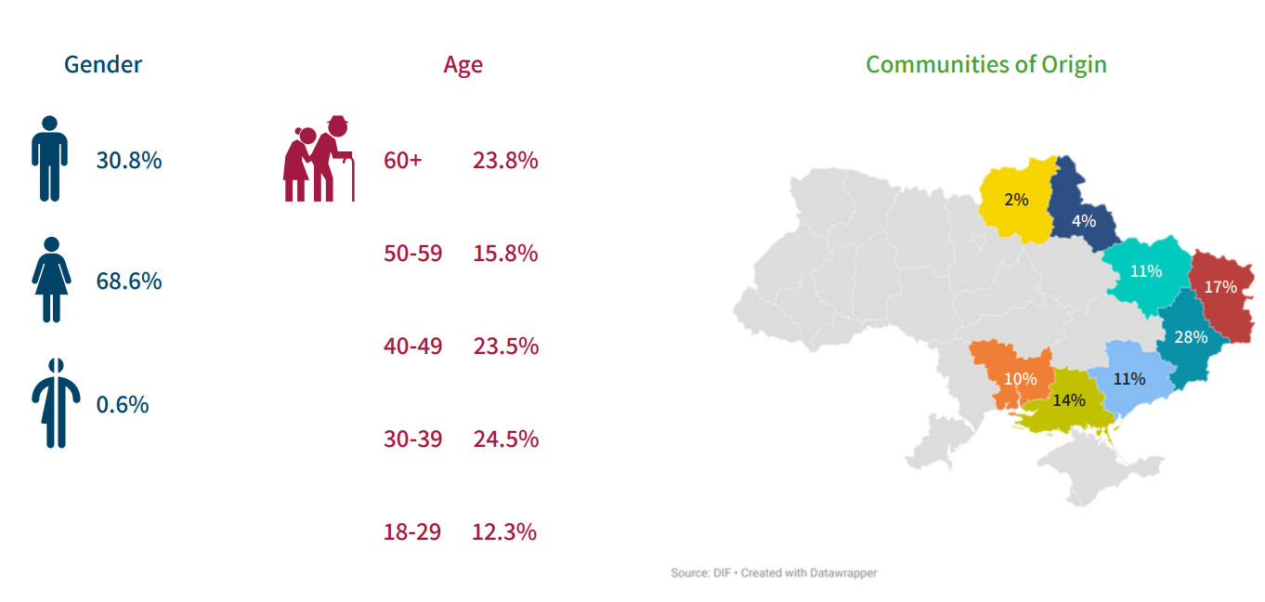
69% of the IDPs interviewed are women and 31% are men. Respondents aged 18-29 (12%) and 59-69 (16%) are the least represented in the sample. Respondents in the other age groups each make up about a quarter of the sample.
Until February 24, the majority of the IDPs resided in the Donetsk (28%), Luhansk (17%) and Kherson (14%) regions. After 12 months of the war the structure of the sample changed significantly due to an increase in the proportion of IDPs from Donetsk, Luhansk, Kherson, Zaporizhzhya and Mykolaiv regions. At the same time, the proportion of IDPs from Kharkiv, Chernihiv, Sumy and other regions has decreased significantly.
49% of IDPs who reside in Dnipro came from the Donetsk region. In Odesa, the majority (40%) of IDPs came from the Kherson region. In Kyiv, IDPs from Donetsk, Zaporizhia, Luhansk and Mykolaiv regions are roughly equally distributed.
The relative majority of IDPs (44%) moved out of their home communities in the spring of 2022. In the first two months of 2023 only 8% IDPs left their communities. A quarter of the IDPs who were forced to leave their communities in spring 2022 settled in Dnipro. The majority of IDPs who left during this most active period of migration came from the Donetsk (29%), Luhansk (22%) and Kharkiv (15%) regions. Those who left this winter came from the Kherson region (30%) and mainly went to Odesa (41%) or Lviv (40%).
The vast majority (51%) of IDPs live in poverty and around 33% of respondents live below the poverty line. After 12 months of the war, the number of respondents living below the poverty line increased by 15% as the proportion of respondents in all other wealth groups decreased. The proportion of IDPs living below the poverty line is highest in Kyiv (45%) and Odesa (48%).
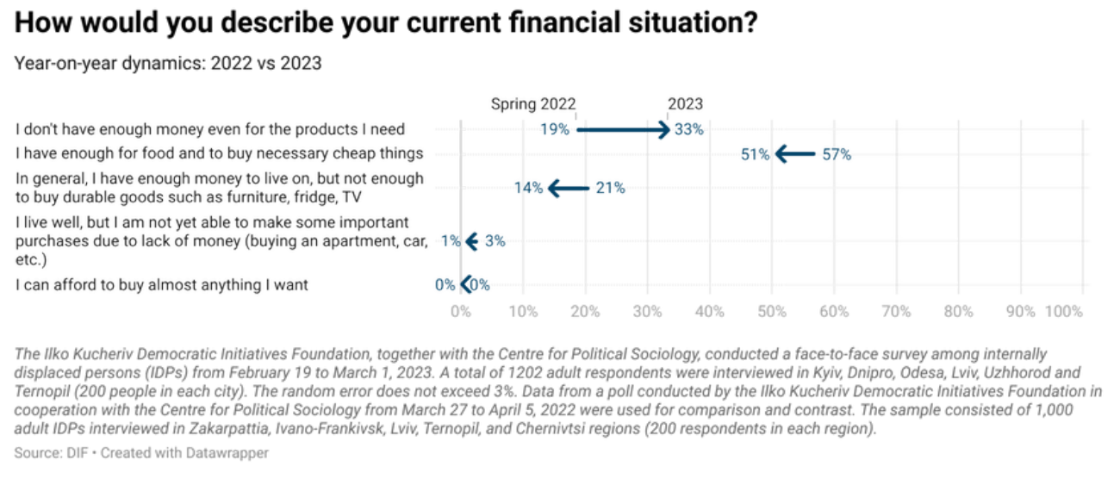
69% of IDPs are unemployed, of which 32% are unemployed due to age or health reasons. The largest proportions of unemployed IDPs of working age who do not have health problems live in Odesa (53%) and Dnipro (46%). The smallest proportion of such unemployed respondents live in Kyiv (18%). The largest proportions of those unemployed due to age or health problems live in Lviv (45%) and Uzhhorod (40%).
Almost all (97%) of the IDPs interviewed are officially registered as internally displaced persons. Young people, members of the middle class and IDPs living in Uzhhorod most often refuse to register.
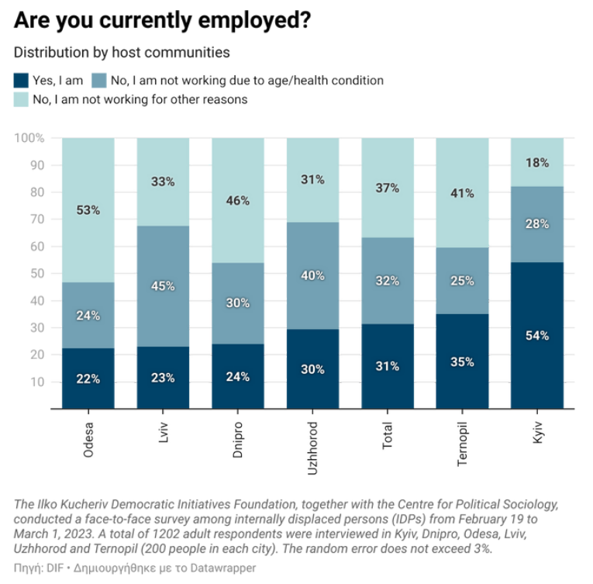
Financial and Material Situation of IDPs
The majority of IDPs live in rented flats/houses (31%) or social/temporary housing provided by local authorities (45%). Only 1% have their own accommodation. 2% do not have a fixed place of residence. After 12 months of the war, the proportion of people living for free with friends/acquaintances/relatives has fallen by 5%.
The housing policy of local authorities in Lviv, Ternopil and Uzhhorod focuses on providing IDPs with temporary housing or social shelters. In Dnipro and Odesa, on the other hand, IDPs have to find accommodation at their own expense. Kyiv is to a certain extent a unique case, as the majority of IDPs (33%) live free of charge with friends/acquaintances/relatives, a quarter of IDPs rent and 7% live in their own flat or house.
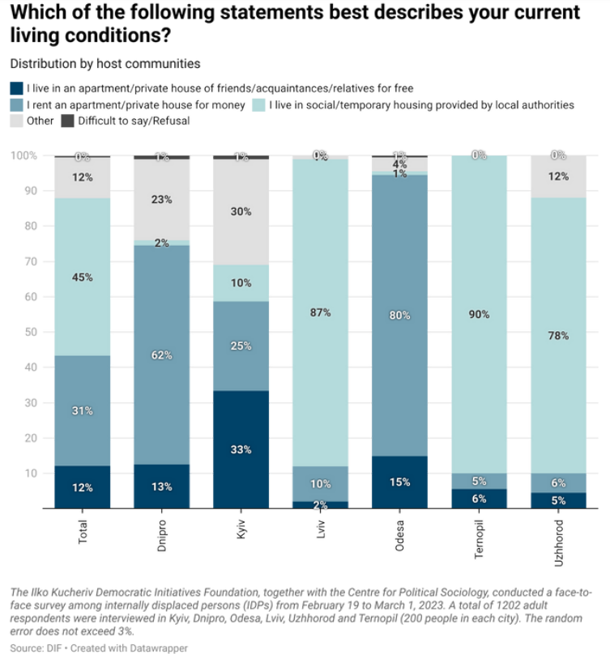
Despite the fact that the vast majority of IDPs had shelters or homes at the time of the poll, 44% are concerned that they will lose access to housing within a year. 6% believe they will lose access to housing in the near future and 10% in the next 2-3 months. Tenants are most concerned about losing their home and expect that it may happen in less than six months.
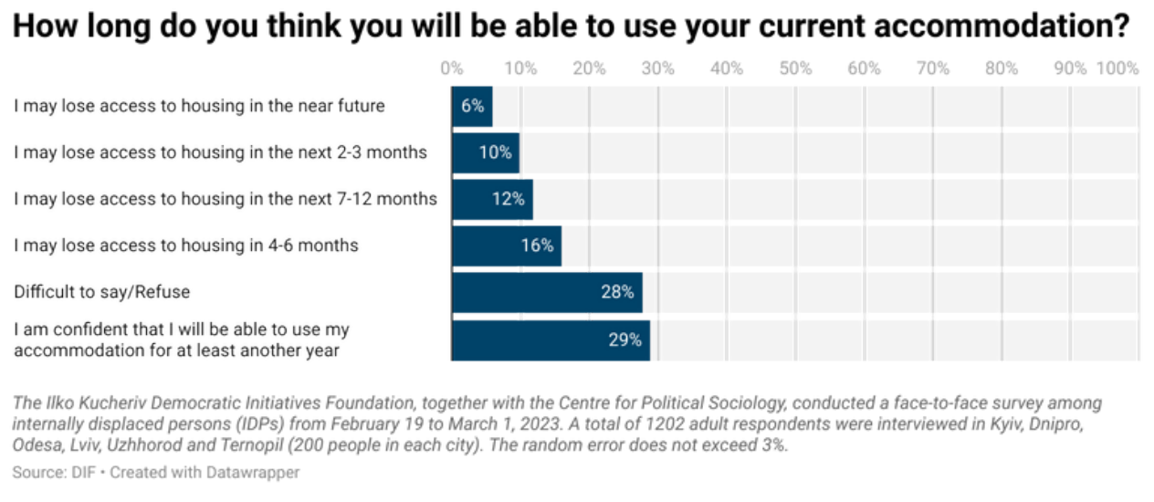
After 12 months of the war, 47% of IDPs have lost their financial savings. At the time of the poll, only 29% had financial savings. Most respondents had enough savings to last a few months (43%) or even less (37%).
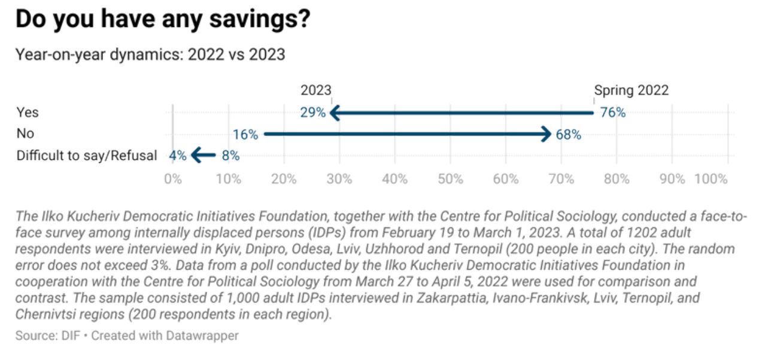
Given the high levels of unemployment and lack of financial savings among most IDPs, it is not surprising that 48% of respondents reported being critically short of money. Over the year, the proportion of IDPs experiencing critical shortages of food (+5%), household chemicals and personal hygiene items (+7%), medicines (+7%) and medical care (+8%) has increased. At the same time, IDPs' access to employment assistance (+21%), administrative services (+19%) and psychological support (+18%) has increased.
At the time of the survey, IDPs were critically short of psychological support (8%), clothing (9%), food (11%), household chemicals and personal hygiene items (13%), medicines (17%), medical care (17%), employment assistance (19%).
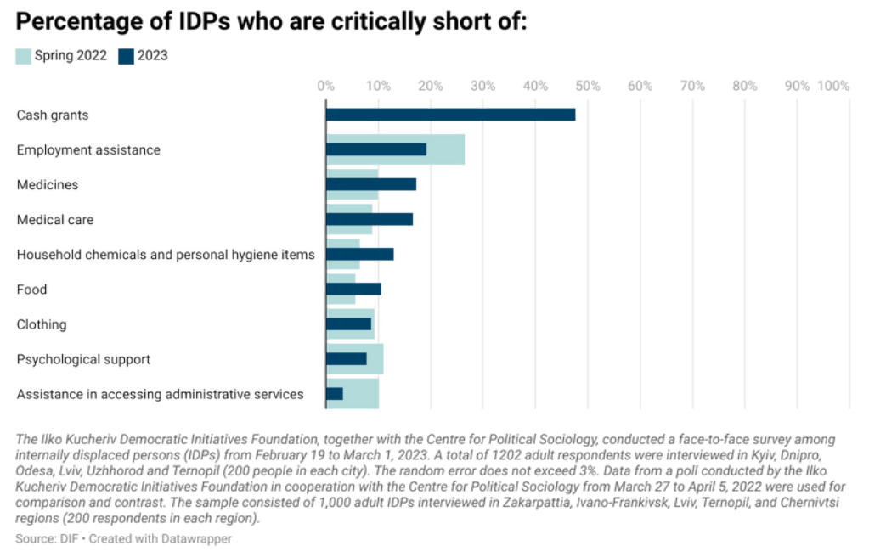
Of the six cities surveyed, IDPs in Kyiv, Odesa and Uzhhorod are most in need of food, clothing, money and medicine. Household chemicals and personal hygiene items are most needed by IDPs in Kyiv and Odesa. In Uzhhorod and Odesa, more than a quarter of IDPs are in urgent need of medical care and employment assistance.
14% of respondents with children need schools and 10% need kindergartens. The lack of places in kindergartens and schools is most relevant for IDPs living in Kyiv. In Lviv, 19% of IDPs reported that their minor children had dropped out of school.
Social and Humanitarian Aid to IDPs
88% of the IDPs interviewed are in need of humanitarian aid. Of these, 38% are in urgent need of humanitarian aid and 50% would not refuse such aid but could somehow manage without it. The highest proportions of IDPs in critical need of humanitarian aid are found in Odesa (67%) and Uzhhorod (49%), and the lowest in Ternopil (21%) and Lviv (23%).
Humanitarian aid is available to the vast majority, but certain humanitarian needs remain unmet. 46% of IDPs in urgent need of humanitarian aid receive it regularly, while another 45% receive it occasionally. At the same time, 12% of IDPs not in need of humanitarian aid receive it regularly and 28% occasionally.
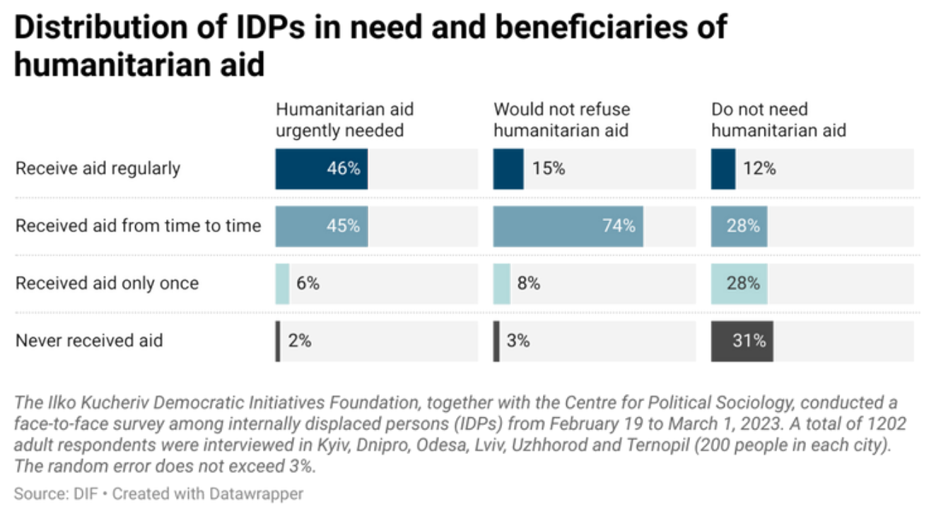
The provision of humanitarian aid is more or less evenly distributed among IDPs from Dnipro, Odesa, Ternopil and Uzhhorod. Around 91% of IDPs received humanitarian aid either regularly or occasionally in the last 6 months. In Lviv, 83% of respondents received humanitarian aid more than once, compared to 67% in Kyiv.
The vast majority of IDPs applied for humanitarian aid themselves, and in 53% of cases humanitarian actors contacted IDPs. In the western cities of the country (Lviv, Ternopil and Uzhhorod), humanitarian actors were much more active than elsewhere. In Odesa, humanitarian actors contacted IDPs in only 8% of cases, in Dnipro 16% and in Kyiv 23%. By contrast, in Lviv, Ternopil and Uzhhorod, humanitarian actors independently contacted IDPs in an average of 91% of cases.
According to respondents, humanitarian aid in the last six months was mainly provided by voluntary/public organisations (68%), international organisations (61%) and government agencies (55%).
52% of IDPs considered themselves informed about the name of the organisation that provided them with humanitarian aid. The most frequently mentioned organisations were the UN (217 mentions), the Red Cross (118 mentions) and UNICEF (103 mentions). A significant proportion of IDPs living in Odesa also mentioned the humanitarian centre “Hostynna Khata” (111 mentions), which is not an international organisation.
Humanitarian aid such as free medical care, employment assistance, cash grants and medicines were received by an average of 22% of IDPs, less than the number of people in need.
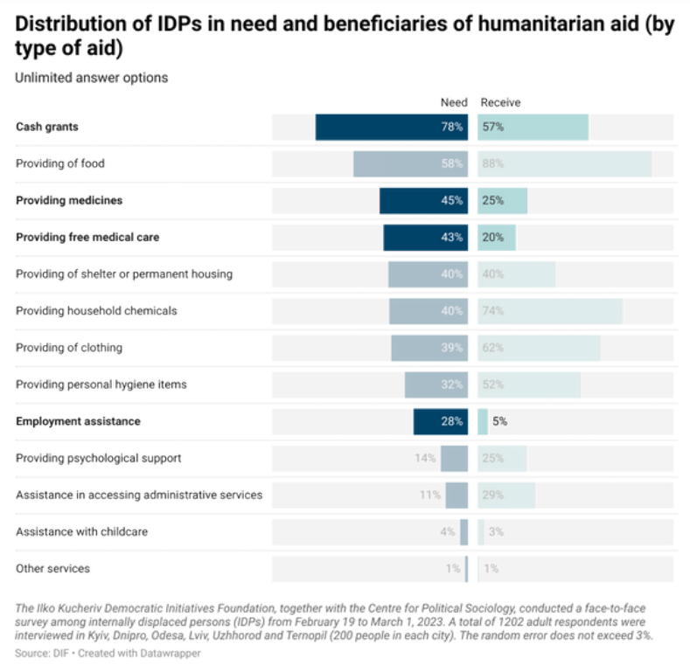
In Kyiv and Uzhhorod, the proportion of IDPs in need of cash grants is significantly higher than the proportion receiving them. In addition, the need for free medical care remains largely unmet in Odesa and Ternopil, and the need for medicines in Odesa and Kyiv.

Integration Into the Host Community
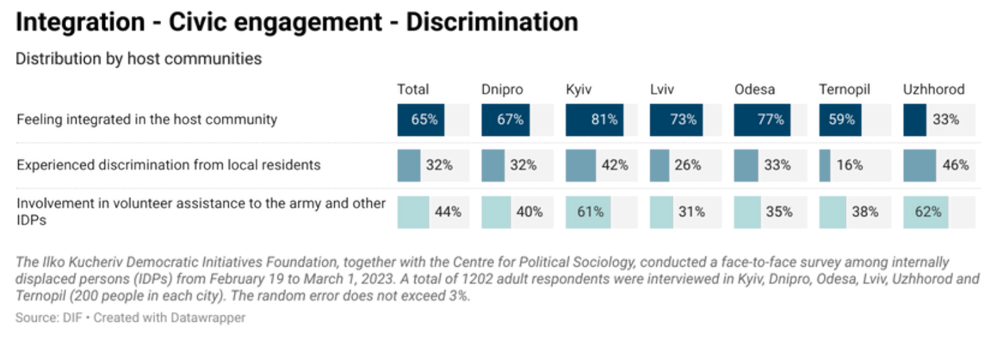
65% of IDPs consider themselves integrated in their host communities. IDPs from Kyiv (81%), Odesa (77%), Lviv (73%) and Dnipro (67%) are the most optimistic about their integration into the host community. At the same time, IDPs in Ternopil (42%) and Uzhhorod (68%) have a much higher proportion of people who do not consider themselves to be full members of their host communities than in other cities.
Self-assessment of integration is lower among elderly respondents, people living below the poverty line and IDPs living in social/temporary housing.
32% of IDPs reported that they had experienced negative attitudes from the local population. Of these, 6% of IDPs experienced prejudice on a regular basis. IDPs living in Uzhhorod and Kyiv reported negative attitudes from the local population most often.
During the year, the proportion of IDPs who volunteered to help the army or other IDPs increased by 15%. At the time of the poll, some 44% were involved in some form of volunteering, mostly physical.
The highest levels of volunteering were found among the IDPs living in Kyiv (61%) and Uzhhorod (62%). In other cities, the share of IDPs involved in volunteering does not exceed 40%. In Odesa and Ternopil, 43% and 42% of respondents are categorically against volunteering.
Respondents who moved to host communities later are less involved in volunteering. They are also more likely to be confident that they will not volunteer.
The vast majority of IDPs (72%) are aware of the existence of IDP support centres, and most have visited them several times (30%). A quarter of IDPs have visited the centres only once. 17% of IDPs visit the centres regularly.

Psycho-emotional State of IDPs
Anxiety (23%), hope (16%), fear (14%) and confusion (13%) remained the most spread emotions among the IDPs.
The vast majority of IDPs are susceptible to negative emotions: 81% feel anxious and 68% fear for their future. Over the course of the year, the proportion of IDPs feeling anxious has decreased by 9%. About 67% of IDPs feel confused about their future. At the same time, 65% of IDPs feel hopeful about their future.
IDPs currently residing in Uzhhorod, Lviv and Odesa are the most anxious and fearful about their future, which can be explained by the variation in the socio- demographic characteristics of IDPs living in different host communities. Anxiety and confusion are highly expressed among IDPs who have left Donetsk and Luhansk oblasts. Respondents originally from Donetsk, Luhansk, Mykolaiv and Kherson regions were more likely to report fear for their future.
The lowest levels of anxiety, fear and confusion were reported by IDPs who left Zaporizhia and Kharkiv regions.
IDPs who moved at the beginning of the full-scale invasion report less anxiety and hope, but more confusion, than those who moved later.
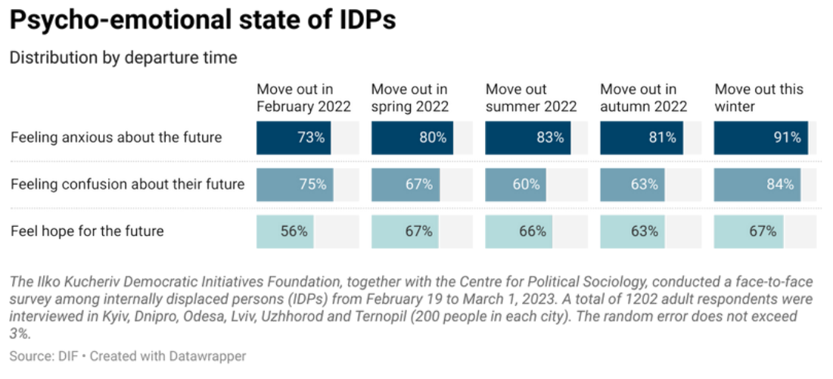
IDPs' gender, age and financial situation are associated with a decrease in the frequency of reports of hope and an increase in anxiety, fear and confusion about their future. Women, the elderly and people living below the poverty line were more likely to report negative emotions.

Migration Intentions
The vast majority of IDPs (55%) ended up in their host community by accident, including because their evacuation transport was heading to that community. Other popular reasons for choosing a host community include feeling safe in the community (25%) and having friends/relatives in the community (16%).
Depending on the city in which the IDPs settled, their motivation for choosing a host community varied.
- To Dnipro: IDPs who had acquaintances/relatives in the city; arrived in the city by evacuation route.
- To Kyiv: IDPs who had acquaintances/relatives in the city; planned to use the city as a temporary location; believed that it was easier to find a job in Kyiv and that the city was safe.
- To Lviv and Uzhhorod: arrived in the city by evacuation route; considered the city safe; wanted to take advantage of the proximity to the EU/European border.
- To Odesa: IDPs who had acquaintances/relatives in the city; arrived in the city by evacuation route; considered the city safe.
- To Ternopil: arrived in the city by evacuation route; believed that it was easier to find accommodation in Ternopil and the city was safe.
After 12 months of the war IDPs have become less (-14%) concerned about proximity to the EU/European border when choosing a host community.
DPs' migration intentions have changed compared to spring 2022. The number of IDPs planning to stay in the host community has increased (+6%) and the number planning to move abroad has decreased (-8%). However, as was the case a year ago, the vast majority of IDPs (53%) plan to return to their communities of origin when the war ends.
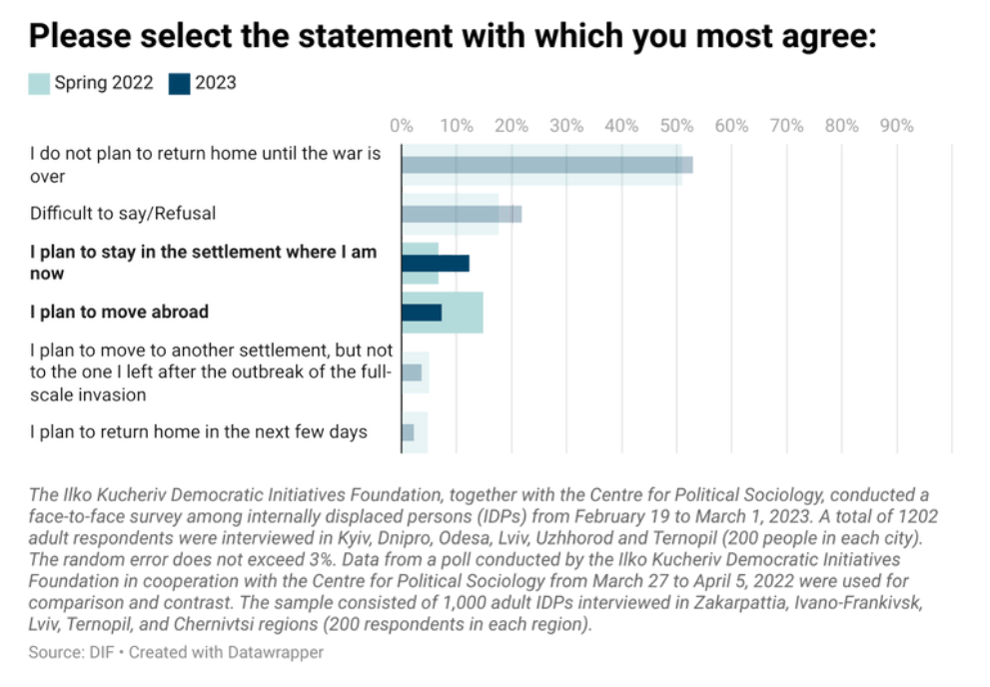
About 6% of IDPs who left Kherson region and 5% who left Kharkiv region plan to return to their communities of origin in the near future.
IDPs planning to move abroad have mostly settled in western cities and Kyiv.
The largest proportion of IDPs planning to settle in host communities are young people, wealthy citizens and IDPs who have avoided discriminatory attitudes from the local population.
Odesa (17%) and Uzhhorod (16%) will face the greatest pressure on social services and the labour market if the proportion of IDPs wishing to stay in host communities does not change. At the same time, settlements in the Zaporizhzhya and Luhansk regions may be most at risk of a shortage of working-age population in the event of de-occupation.

