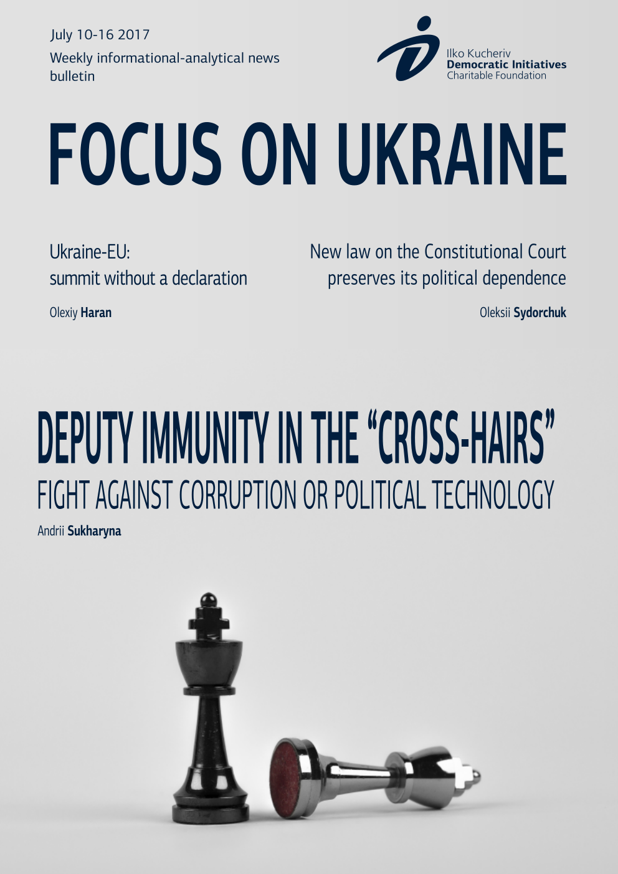

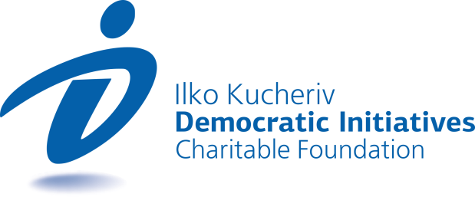

TOPICS
DEPUTY IMMUNITY IN THE “CROSS-HAIRS”: FIGHT AGAINST CORRUPTION OR POLITICAL TECHNOLOGY 3
UKRAINE-EU: SUMMIT WITHOUT A DECLARATION 5
NEW LAW ON THE CONSTITUTIONAL COURT PRESERVES ITS POLITICAL DEPENDENCE 7

DEPUTY IMMUNITY IN THE “CROSS-HAIRS”: FIGHT AGAINST CORRUPTION OR POLITICAL TECHNOLOGY
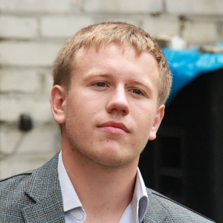  Andrii Sukharyna  Political analyst, Ilko Kucheriv Democratic Initiatives Foundation | Last week on July 11 and July 13, the Verkhovna Rada reviewed the case filed by the Prosecutor General of Ukraine on stripping 6 people’s deputies from 5 different factions and parliamentary groups of their immunity. Boryslav Rosenblatt, Maksym Polyakov, Yevhen Deidei, Andriy Lozoviy, Oles Dovhiy and Mykhailo Dobkin came into the field of vision of investigations launched by the National Anti-corruption Bureau of Ukraine (NABU), the Specialized Anti-corruption Prosecutor (SAP) and the Prosecutor General’s Office of Ukraine (PGO).
These events turned the attention of political experts and broad layers of the public first of all by their scale, as well as the general level of political discussion that carried on throughout the week. The review of these cases also once more demonstrated the heterogeneity of the parliamentary coalition, as well as other political forces in the parliament and the presence of informal groups within them. While so far it is too early to speak of the prospects of investigations and all the more judicial reviews, the rise in tension in the parliament and manifestations of hidden principles of solidarity among representatives of the establishment can be affirmed.
Unlike in previous cases of the NABU and the GPO against people’s deputies, this time there is less talk about political persecution, seeing as 3 of the 6 deputies against whom cases were filed represent the effective coalition in the Verkhovna Rada. Moreover, the pro-presidential political force at least publicly alienated itself from its representative Rosenblatt and expelled him from the faction. However, the situation with other deputies under investigation is somewhat different. Representatives of the Opposition Bloc, the Radical party, The Will of the People and, to a lesser extent, the People’s Front demonstrated that they put forth all efforts to “defend” their own.
The most resonant case is that of deputy Boryslav Rosenblatt of the Petro Poroshenko Bloc (PPB), who is accused of receiving a bribe of nearly US $300,000 that he demanded and received from the representative office (in truth, special undercover agents of the NABU) of a company registered in the United Arab Emirates for “aiding and abetting” the extraction of amber. In order to strengthen the effect of the committed crime, deputies were even shown a “film” about how Rosenblatt received his cut from this bribe at a hearing of a regulatory committee.
Documenting and fixation of the criminal case was truly executed at a high level, which is why people’s deputies could not turn a blind eye to these facts. Furthermore, journalists even compiled a “restaurant map” of places where the key events of the investigation took place on the basis of the facts made public by the NABU.
However, among all six of the cases files the parliamentarians managed to vote not only for the stripping of immunity, but also for the possibility of further arrest, in the case against Mykhailo Dobkin. As for Yevhen Deidei and Andriy Lozoviy, for now they avoided continuation of investigations seeing as the parliament did not give its consent to this.
It is also worth considering two aspects, the discussion of which was initiated as a result of the filing of these investigative cases on stripping immunity:
The first aspect relates in general to the issue of deputy immunity.
Cancelling of deputy immunity is one of the main promises of a large number of political forces, which were never fulfilled.
Today, Ukrainian parliamentarians have absolute immunity: without the consent of the VR they cannot be prosecuted neither for actions committed within the framework of fulfillment of duties and obligations and the powers of people’s deputies (which is a standard practice), nor for actions committed beyond the scope of parliamentary activity and which are not directly related to them (which does not correspond to commonly applied democratic norms).
Today, if not cancellation, then at least certain limitation of deputy immunity seems appropriate. At the same time, it is highly unlikely that people’s deputies will take such a step. But the fact that the work of the NABU continues to be activated and the cases of the PGO are assuming certain regularity, then the chances that the parliamentarians will want to deprive themselves and their colleagues of additional defense from criminal investigations are becoming even less. For this very reason, it is not worth expecting the limitation of deputy immunity in the foreseeable future.
The second aspect touches upon the effectiveness of the further work of the Verkhovna Rada.
There are doubts as to the readiness of further working and reaching an agreement with the coalition on voting for the “necessary” bills, first and foremost, those proposed by such political forces as the Will of the People and the Opposition Bloc. There are grounds to affirm that they are not likely to cooperate with pro-presidential forces after submissions for stripping Dovhiy and Dobkin of their deputy immunity were filed and voted for.
Such tension in the Verkhovna Rada and the activation of the work of anti-corruption bodies could have far-reaching consequences. It is totally possible that as early as this autumn, when the Verkhovna Rada is once again in session, the possibility of reaching a compromise for the support of the initiatives of the President or the government will be extremely narrow. Clearly, another scenario when the Prosecutor General’s Office enters the political playing field and applies pressure on all other members of the legislative body for the political aims of the ruling power cannot be ruled out.
At the same time, these investigations could be an excellent opportunity for President Poroshenko to improve his electoral chances through the hands of the Prosecutor General, who is close to the president. In society, where there is a powerful request for social fairness and the fight against corruption in the higher echelons of power, the active work of the PGO will most likely be positively welcomed. However, any actions will not have any radical effect without the logical conclusion of court proceedings, which at the moment presents a certain problem for the Prosecutor General’s Office.

UKRAINE-EU: SUMMIT WITHOUT A DECLARATION
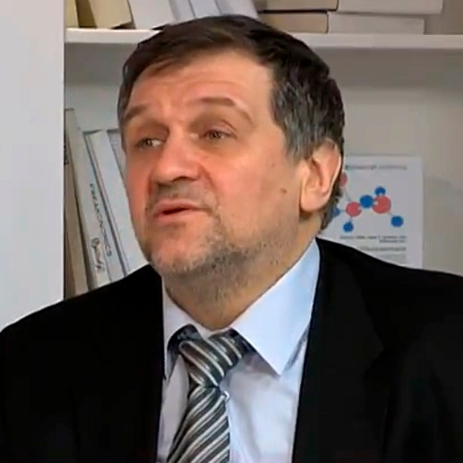  Olexiy Haran  Research Director of the Ilko Kucheriv Democratic Initiatives Foundation | The 21st annual Ukraine-EU Summit held in Kyiv on July 12-13 ended without the approval of a declaration traditional for this event. But we should not dramatize this fact. The joint declaration was not approved for one reason: Kyiv insisted that a phrase from the Association Agreement on the support of Ukraine’s “European aspirations” be included in the declaration.
The essence of the summit lies in the fact that it opened a new stage of cooperation between our country and the EU. That is, the Association Agreement is fully and finally ratified meaning that it will not only take effect de-facto, but henceforth it is absolutely legally secured. This, in turn, means that we received the “roadmap” of our transformations, which we will implement jointly with the EU. Also, the visa-free regime for short-term travel of Ukrainians to the EU took effect. All this combined is indeed a transition of our relations with the EU to a new stage.
The closed notifications that were voiced over the course of the summit envisaged the signing of well-drafted declaration on seven pages where the implementation of these issues was to be written in detail according to the provisions of the Association Agreement.
Why was this declaration not signed and why were the provisions on the support of Ukraine’s European aspirations not included in it? In my opinion, this is more associated with domestic policy considerations. It is known that this was the position of the Netherlands – not to repeat this wording. We recall that earlier a consultative referendum was held in the Netherlands, which complicated the process of final ratification of the Association Agreement for Ukraine (now the Russian intervention into the preparations of a referendum that we earlier referred to is already common knowledge). But we pulled out of the situation with the help of the EU, the Dutch and the Ukrainian diplomatic corps.
Nevertheless, in the Netherlands there remains a certain reservation – they do not want to promise Ukraine the prospect of membership in the EU. In the end, the position of the Netherlands was supported by Germany and France through closed notifications. But all this is more likely an appeal to voters in these countries and to that part of society in these countries who fear the expansion of the European Union.
However, Ukraine’s “European aspirations” do not mean that Ukraine is automatically moving towards membership in the EU. This is simply a fixation of the current stage. In the EU just as in Ukraine there are claims to the Ukrainian authorities. Let’s say, as to why the fight against corruption is slowing down. These claims exist and are discussed and are echoing at the highest official levels. And I feel that it is not a bad thing that the EU is putting pressure on Ukraine to implement the necessary changes.
But the Ukrainian side in the given situation was faced with a dilemma – either sign a major declaration based on the results of the summit without the aforementioned phrase, or sign no document at all. Weighing the “for” and “against”, Ukraine decided that including this clause is a matter of extreme principle for it. And if Europeans, more precisely – three countries – do not want to do this then let them ponder the question why exactly. Therefore, Kyiv to a certain degree aggravated the situation and put the question point blank saying to the EU: “European Union, where is your adherence to principles? If this is written in the Association Agreement, then why are you afraid of repeating this?”
In this way we showed the Europeans that we will not sign everything based only on EU considerations. We have our own domestically consolidated position on “European aspirations”, we have the support of society and in the end Ukrainians have perished and are perishing on the front fighting for the European idea. This is why we returned the ball to the court of the EU and said: “European Union, think about your values. After all, your position must be a matter of principle and should be consistent.”
I stress that with respect to the implementation of the Association Agreement, this does not change a thing. We will continue to move further ahead, we will continue to receive assistance from the EU and we do our “homework”, because this is, first and foremost, in our interests..
Original: UNIAN

NEW LAW ON THE CONSTITUTIONAL COURT PRESERVES ITS POLITICAL DEPENDENCE
Olexii Sydorchuk  Political analyst, Democratic Initiatives Foundation | On July 13, the Verkhovna Rada adopted the law “On the Constitutional Court of Ukraine”, which for the first time will regulate the activity of this body by a separate legislative act. It was called on to bring the functioning of the Constitutional Court of Ukraine (CCU) in correspondence with the new edition of the Constitution, which took effect on September 30, 2016.
The need to adopt a law on the CCU did not evoke any doubts neither in the political, nor in the expert environment. On the one hand, despite the fact that after the Revolution of Dignity the current composite of the CCU lost a significant bulk of its legitimacy, its revamping was not completed, particularly due to the unregulated procedure of selection of its judges. On the other hand, even after 2014 the CCU remained politically dependent on the subjects of its appointment, first and foremost on President Petro Poroshenko. As a result, over the past years the CCU was not capable of effectively executing its functions. A brilliant testimony to this was the fact that the CCU has not issued any ruling since the start of 2017.
The most acute problem that needed legislative regulation pertained to the guarantee of the independence of the courts of the CCU. The changes to the Constitution approved in 2016 made a step forward by establishing that judges will be selected on a competition basis according to the procedure set by the law. However, the norms of the new law do not create favorable conditions for greater independence of judges.
First of all, the law allows three bodies, which appoint six judges of the CCU each – the President, the Verkhovna Rada and the Congress of Judges – to form a competition commission at their own discretion. Therefore, the commissions will most likely be fully dependent on the political bodies that create them and for this reason will select politically loyal judges. Secondly, the law does not regulate at all the procedure of selection of candidates for the post of a CCU judge, which again allows the president and the parliament to control the activity of the competition commissions and influence the selection of judges.
The procedure of dismissal of CCU judges remains problematic as well. The new edition of the Constitution envisaged that judges can only be dismissed by the decision of the CCU and introduced new grounds for this – gross or systematic neglect of their duties. The law repeats this wording, though it does not explain what specifically can be considered such grounds. Given the danger that the majority of new CCU judges will remain politically dependent on the president or the parliament, those of them who will demonstrate their independence will end up under the threat of being dismissed for precisely such an undefined motive. To sum it up, the new law leaves the acting and future CCU judges extremely vulnerable to political pressure.

“Focus оn Ukraine” – weekly informational-analytical news bulletin prepared by the
Ilko Kucheriv Democratic Initiatives Foundation (http://dif.org.ua).

DIF Analysts:
Iryna Bekeshkina
Oleksiy Haran
Ruslan Kermach
Oleksiy Sydorchuk
Maria Zolkina
Аndriy Sukharyna
Editor-in-chief: Iryna Filipchuk
Cover and layout: Illia Sverhun

How the NABU and the PGO investigated the “Amber”scheme. Film // https://youtu.be/maD-Fhqr-rY
On Saturday, July 15, 2017, the Pechersk Court of Kyiv chose to take a precautionary measure by holding Mykhailo Dobkin in detention on bail in the amount of UAH 50 mn.

