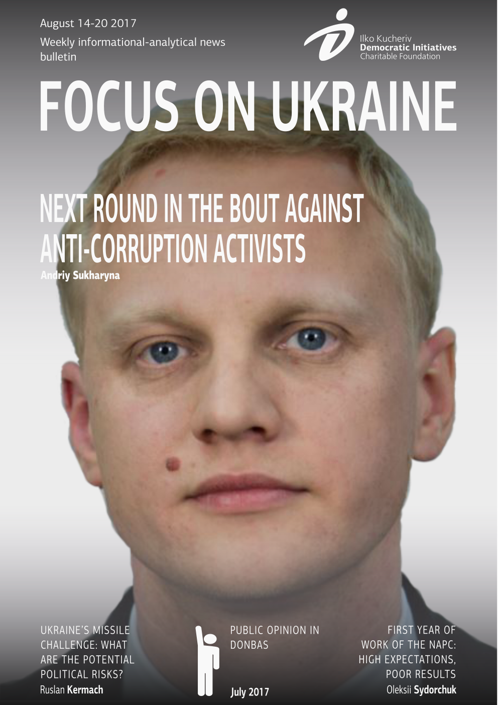

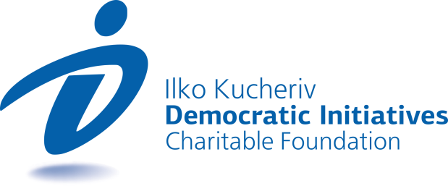

TOPICS
NEXT ROUND IN THE BOUT AGAINST ANTI-CORRUPTION ACTIVISTS 3
UKRAINE’S MISSILE CHALLENGE: WHAT ARE THE POTENTIAL POLITICAL RISKS? 4
FIRST YEAR OF WORK OF THE NAPC: HIGH EXPECTATIONS, POOR RESULTS 7
PUBLIC OPINION IN DONBAS: JULY 2017 8

NEXT ROUND IN THE BOUT AGAINST ANTI-CORRUPTION ACTIVISTS
Andrii Sukharyna  Political analyst, Ilko Kucheriv Democratic Initiatives Foundation | On August 16, the Kyiv Prosecutor General’s Office informed about suspicions of “deliberate infliction of minor bodily injuries, which stipulates 3-year imprisonment, to the head of the non-government organization “Anti-corruption Center” and the renowned civil activist Vitaliy Shabunin. On this day, he was obliged to inform the court about change of his place of residence and work. As a reminder, on July 8 of this year there was a conflict between Shabunin and the blogger Vsevolod Filimonenko who calls himself a journalist. After a few provocations, Shabunin punched Filimonenko in the face.
The incident in which Shabunin was suspected smacks more of a motivated persecution of an opposition civil activist than establishing justice. Possibly forged medical conclusions and an unfair choice of a criminal article, which could put Shabunin behind bars, point to this fact. In addition to that, there are well-grounded suspicions that Filimonenko executed a task of the Security Service of Ukraine, which was following every step of the activist. In the end, far more serious incidents of attacks on the journalist, for example investigators of the program “Our Money”, did not incite any reactions of law enforcement bodies.
Though it is impossible to speak of direct complicity of high-standing government officials in the Shabunin case, the absence of any reaction to it on the part of the president leads one to conclude that this case is totally in his interest. There may be a few motives behind this. First of all, discrediting one of the key anti-corruption activists, who regularly acts against the interests of the ruling elite, for instance on the issue of electronic declarations. Secondly, it is quite probable that in this way representatives of the ruling power are trying to obstruct Shabunin from running for a seat in parliament in the upcoming elections due to his criminal record.
The case with the filing of criminal proceedings against Shabunin can be viewed in the context of increased pressure on anti-corruption activists and certain politicians from the opposition. The amendments to the law on electronic declarations, which pose a threat to the effective work of all non-government organizations that are directly or indirectly related to the fight against corruption, can be added to this list. The stripping of Ukrainian citizenship of Mikheil Saakashvili, the criminal proceedings against the former prosecutor general deputies Vitaliy Kasko and David Sakvarelidze, the search of the residences of ex-head of the Odesa Customs Office Yulia Marushevska, the persecution of investigative journalists of the Kyiv media program “Skhemy: Corruption in Detail” and investigative journalists of the Rivne oblast human rights organization “Investigative Journalism Agency”.
Such a situation has a negative impact not only on the tense socio-political atmosphere in Ukraine, but also on how Ukraine is perceived by the West. At the same time, there are fears that the pressure of the government on the non-government sector will be enhanced seeing as this trend has been observed for quite some time now. At the moment, it is difficult to judge how the criminal case against Shabunin will end, however this process is another alarm bell regarding the escalation of relations of the government with civil society.

UKRAINE’S MISSILE CHALLENGE: WHAT ARE THE POTENTIAL POLITICAL RISKS?
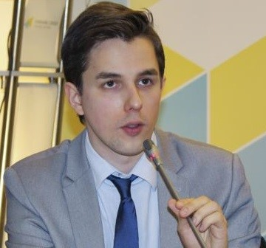  Ruslan Kermach  Political analyst, Democratic Initiatives Foundation | A few days ago, a sensational article was published by the The New York Times with the eloquent headline “North Korea’s Missile Success Is Linked to Ukrainian plant, Investigators Say”. The authors of this article made reference to an interview of a missile expert of the International Institute for Strategic Studies (IISS) Michael Elleman, who voiced his presumption that the Ukrainian state enterprise “Pivdenmash” could be the “most probable source” of engines for North Korean missiles, which were successfully tested in July of this year. Later, the press service of the “Pivdenmash” enterprise denied such information. Secretary of the National Security and Defense Council of Ukraine Oleksandr Turchynov, in his turn, noted that Ukraine complies with all international obligations it assumed and did not supply any arms or military technology to North Korea.
Not accusation but a presumption?
First of all, it is important to note that in the text of the aforementioned publication of the NYT no direct allegations were made against Ukraine and its leadership, rather only presumptions of the possibility that RD-250 engines manufactured in Ukraine ended up in North Korea, for instance, from the black market. The accent in the article has significant meaning since the rocket engines manufactured in Ukraine did not necessarily arrive to North Korea directly from Ukraine.
In light of the long history of joint industrial cooperation of Russian enterprises with Ukrainian companies, including in the sphere of rocket design and construction, the possibility that technology or RD-250 engines manufactured in Ukraine ended up in North Korea through the Russian enterprise “Energomash” as an intermediary cannot be ruled out. As missile expert Michael Elleman noted, it is possible that the corresponding excess engines are currently being stored in Russian warehouses.
Besides that, as acting head of the State Space Agency of Ukraine Yuriy Radchenko noted during a recent briefing, the RD-250 engines were produced in Ukraine only up to 2001 in the interests of Russia and were supplied there as part of a space rocket. Herewith, as Radchenko affirmed “Ukraine did not independently execute any deliveries from the moment it became independent over the period that the use of this equipment was mastered”.
In the assessments of hypothetical possibilities of the supply of rocket engines from Ukraine the factors of the considerable territorial distance between Ukraine and North Korea and the absence between the two countries of a common border should also be taken into account. Purely from a logistical point of view it makes the possibility of the alleged direct contraband of the aforementioned engines from Ukraine far too complicated task. It is considerably easier to realize such a scenario through the adjacent to the DPRK territories of Russia or China with whom Pyongyang, among other things, collaborates with in the spheres of defense and security.
Potential political risks
Despite the fact that direct accusations have after all not been made against Ukraine while the suspicions set out in the sensational article of the NYT are rather hypothetical in nature, this story could potentially have a negative impact on Ukraine’s international reputation as well as on its relations with the United States. As it is known, the U.S. assumptions about the ostensible supply by Ukraine of the ‘Kolchuga’ radar system to Iraq in 2002 has never been proven by the American side, which however did not prevent this story from becoming a factor of notable cooling of relations between official Kyiv and Washington at that time.
Alongside this the latest official reaction of the U.S. Department of State regarding the alleged supply of rocket engines manufactured in Ukraine to North Korea was relatively reserved and level-headed. Indeed, the official representative of the U.S. Department of State Heather Nauert in a recent briefing informed that Washington’s “position on this issue (regarding the supply of rocket engines to North Korea - auth.) is very serious if this information is confirmed”. Moreover, the spokesperson of the U.S. Department of State noted that Ukraine “has a reliable history of efforts in the sphere of non-proliferation, especially regarding North Korea”. In connection with this there are certain grounds to consider that in the event of operative provision by the Ukrainian side of incontrovertible evidence of non-complicity in the supply of rocket engines to North Korea, the sensational story based on the NYT publication will not lead to any worsening of bilateral relations between Ukraine and the U.S.
However, the pop up of the unconfirmed information that casts a shadow of doubt on Ukraine is today capable of indirectly influencing Washington’s current debate on the possibility of providing Ukraine with lethal defense weapons. The appearance of the compromising material regarding Ukraine right at the stage of serious consideration of the aforementioned issue in the White House might serve as indirect testimony to the motives that could potentially be behind its appearance at this given moment.
After all, the possibility of providing Ukraine with lethal defense weapons is currently a heated issue of debate in Washington and a final decision has not yet been made. In connection with this, even unconfirmed information that could one way or another point to the fact that Ukraine is ostensibly incapable of effectively controlling strategically important technologies or weaponry could instill a significant level of fear in Washington. This, in its turn, could tip the scale in favor of those representatives of the American establishment who do not support the idea of granting Ukraine with lethal defense weapons because of the alleged unreliability of Kyiv and posing high risks of American strategic weapons falling into “third hands”.
In order to minimize the aforementioned risks and accusations the official authorities of Ukraine and diplomats should convincingly confirm by submission of all necessary documentation and factual information the non-complicity of Kyiv in the supply of any kind of rocket technologies to Pyongyang, as well as substantiate the impossibility of effectuating such supplies through export channels due to the international obligations which Ukraine complies with regarding, in particular membership in the Missile Technology Control Regime (MTCR). Taking the initiative in organizing an international investigation regarding how the notable progress in the development of the North Korean nuclear missile program of late became possible would also be a significant step in the process of “whitewashing” the international image of Ukraine on the backdrop of the currently unfavorable information background.
Original: Ukrainian Interest

FIRST YEAR OF WORK OF THE NAPC: HIGH EXPECTATIONS, POOR RESULTS
Olexii Sydorchuk  Political analyst, Democratic Initiatives Foundation | August 15 marked a year from the official start of work of the National Agency for the Prevention of Corruption (NAPC). On this occasion, Director of the NAPC Natalia Korchak and head of the Civil Council at the NAPC Viktor Taran held a special briefing at which they reported the results of the first year of work of the anti-corruption body. While the head of the NAPC for the most part spoke about the achievements of her agency, the assessment of the civil society representative was considerably more critical. That day the Competition Commission of the NAPC elected the fourth member of this body (to replace Ruslan Riaboshapka, who tendered his resignation in June of this year). After approval of his candidacy by the Cabinet of Ministers the new member of the NAPC will be the lawyer Oleksandr Seryohin. On August 18, another member of the NAPC Ruslan Radetskyi unexpectedly tendered his resignation.
Over the first year of its functioning, the NAPC was overall unable to meet fairly high expectations, which society had placed on the agency. The results of its activity in two of the most crucial areas of its responsibility – review of electronic declarations of officials and politicians and control over party finances – left much to be desired.
In particular, over a year the NAPC managed to review only 39 electronic declarations of the total amount of nearly 1.5 million declarations for the period 2015–2016 it received. Moreover, the results of these reviews cast doubts regarding their diligence, seeing as in the declarations of top officials under review it found only a few minor technical discrepancies. There are several reasons for such poor results. First of all, the launch of electronic declaration was dragged out for too long, including due to the inactivity of the NAPC. Secondly, the effective procedure of review of electronic declarations is far from perfect as it does not allow for automatic comparison of data in declarations with state registries, which forces the NAPC to execute all reviews manually. Finally, there are suspicions regarding the political dependence of the NAPC on President Petro Poroshenko and the Cabinet of Ministers, which similarly can obstruct this body from meticulously reviewing declarations of high-standing officials.
Control over the financing of political parties on the part of the NAPC also gives grounds for ambiguous assessments. On the one hand, the NAPC managed to streamline the process of review of party reports and bring certain violators to criminal liability. On the other hand, the current system of sanctions implies that the majority of violators will only have to pay a minimal fine, while those political forces that do not submit financial reports can completely evade any responsibility. Besides that, as in the case with electronic declarations, the review of party reports conducted by the NAPC raise suspicions of the existence of political motives in the decisions of this body. Indeed, so far the NAPC has attempted to investigate wrongdoings of only opposition political forces, while this body has not take similar actions against the Petro Poroshenko Bloc Solidarnist or the Popular Front.
If the suspicions of the susceptibility of current members of the NAPC to political pressure are true, the election of a new member is not likely to have a serious effect on the activity of the anti-corruption body. In light of the resignation of Radetskyi, however, the scenario offered by the Ministry of Justice of full re-election of the composition of the NAPC by holding a new competition seems more likely. It, though, may backfire with the strengthening of influence of the executive body of power on the work of the NAPC. In any case, the effectiveness of the work of the NAPC, be it in the current composition or after its “reload”, will to a great extent depend on the capacity of civil society to consolidate its efforts for the sake of constant control over NAPC activity and providing active support to this body when it needs it the most.

PUBLIC OPINION IN DONBAS: JULY 2017
Ilko Kucheriv Democratic Initiatives Foundation  Public opinion poll results | The Ilko Kucheriv Democratic Initiatives Foundation (with engagement of the "Ukrainian Sociology Service" network) carried out polling on government-controlled territories of Luhansk and Donetsk regions: July 1-11, 2017 in Donetsk region and July 8-26, 2017 in Luhansk region. In general, 500 adult respondents from each of the regions (except for occupied territories) were polled based on representative sample. The sample is representative in terms of such indicators as gender, age, education and place of residence. Margin of error amounts to 4.6%.  The polling was carried out under the project "Reintegrating Donbas by raising public participation in solving key problems of local communities" with financial support of the British Embassy in Ukraine.
Data of nationwide polling conducted by the Ilko Kucheriv Democratic Initiatives Foundation (funded by "MATRA" Program of the Embassy of the Kingdom of Netherlands in Ukraine) in June 2017 are provided for comparison purposes.
- Both majority of the population in Donetsk and Luhansk regions support enlargement of powers and resources of local government administrations: 49% of respondents in Luhansk region and 50% of respondents in Donetsk region fully or rather support decentralization. At the same time, population has different views on consequences of decentralization, which range from optimistic (20% of respondents in Luhansk region and 14% of respondents in Donetsk region believe that citizens will get new means of influence on authorities, 27% of respondents in Luhansk region and 29% of respondents in Donetsk region expect that quality of services provided to citizens will improve) to pessimistic (17% of respondents in Luhansk region and 22% of respondents in Donetsk region are rather afraid of more rapid desolation of villages as a result of decentralization processes, while 14% of respondents in Luhansk region and 29% of respondents in Donetsk region believe that processes of enlargement of powers of local authorities will lead to appearance of local "princelings"). In general, citizens of Donetsk region are more pessimistic about decentralization than citizens of Luhansk region: 52% of respondents in Donetsk region and 30% of respondents in Luhansk region expect negative consequences, while differences in levels of optimism are smaller: 47% among respondents in Luhansk region and 43% of respondents in Donetsk region (each third citizen of Luhansk region is undecided).
- At the same time, majority of the population of both Donetsk and Luhansk regions (49%) has not noticed any changes resulting from use of additional funds received by local budgets during the recent years. However, in Luhansk region, more people have noticed a change for the better (28% as compared with 21% in Donetsk region) and less people have noticed a deterioration (19% as compared with 24% in Donetsk region). As compared with other regions, Donbas – along with Western Ukraine – is a region where the largest share of population has noticed a change for the better (16% on average in Ukraine) and, at the same time, along with South of Ukraine it is a region where the largest share of population has noticed deterioration (16% on average in Ukraine).
- In both regions, doubts whether local authorities will manage to cope with new powers they will get in the course of decentralization prevail. Citizens have become less confident about it during the recent year: fully confident respondents account for 10% (15% in 2016), rather confident respondents account for 32% (37% in 2016), while 29% of respondents have strong doubts about it (20% in 2016), and 17% believe it is not possible (10% in 2016). The largest share of those confident in capabilities of their local authorities is observed in Western Ukraine (50% of "fully" or "rather" confident respondents), while the lowest share is observed in the South of Ukraine (32%).
- 38% of respondents in Luhansk region and 34% of respondents in Donetsk region believe that urgent problems of their cities (villages) are being more or less solved. Financial and social issues are considered by respondents to be the most urgent: resumption of enterprises operation, new jobs creation (64% in Luhansk region and 50% in Donetsk region), increase of pensions, salaries and welfare benefits (42% and 40% respectively), restoration of destroyed infrastructure (44% and 25%), organization of medical servicing (33% and 23.5%). Among these issues, only problems of restoration of destroyed infrastructure are being solved successfully (it was noticed by 17% of respondents in Luhansk region and 25% of respondents in Donetsk region). A large share of population has not noticed a single problem solved successfully (49% in Luhansk region and 52% in Donetsk region).
- If citizens of the region could distribute local budget, they would allocate most of the funds for encouraging of economic growth – resumption of enterprises operation and new jobs creation (63% in Luhansk region and 56% in Donetsk region). Other priorities include repairs and improvement of infrastructure (56% in Luhansk region and 28% in Donetsk region), increase of welfare benefits for disabled and retired persons (22% and 36% respectively), improvement of medical servicing (25% and 27%), city/village public welfare (24% and 20.5%), helping people to start small and medium business (26% and 17%).
- A large share of citizens in Luhansk and Donetsk regions (32% and 38% respectively) experience problems in protecting their rights: mainly economic rights (44% in Luhansk region and 35% in Donetsk region) and rights to social protection (34% in Luhansk region and 15% in Donetsk region). At the same time, a certain share of the region's population experiences problems with the right to safety and protection by the state (12% in Luhansk region and 9% in Donetsk region).
- As compared with other regions of Ukraine, Donbas demonstrates greater readiness for peace "at any price" (41% of respondents). Both in Donetsk and Luhansk regions, share of citizens who support any compromise (44% and 38% respectively) is slightly higher than share of those who believe that not all compromises are acceptable (39% and 34%). At the same time, Donbas also demonstrates the lowest share of those who believe that peace may be restored by force only.
- In opinion of 38% of Donbas residents, successful restoration of normal life on territories controlled by Ukraine is a key to resolve the conflict. At the same time, 22% of respondents (32% in Donetsk region and 12% in Luhansk region) believe that forcing Russia to stop intervening into the Donbas conflict (tightening of international sanctions, international institutions' pressure on Russia) is an efficient step towards conflict resolution. Granting "DPR" and "LPR" special status within territory of Ukraine (14%), declaring Russian as the second state language (14%), and refusal from prospects of joining NATO (12%) are less popular steps towards peace according to respondents.
- Half of respondents in Donetsk and Luhansk regions (49%) have relatives and friends who live on uncontrolled territories of Donbas. Absolute majority of them maintains some kind of contact with them (93.5% of those who have relatives on uncontrolled territories in Luhansk region and 88% of those in Donetsk region). Intensity of contacts between residents of controlled and uncontrolled territories is higher in Luhansk region (57% of respondents maintain regular contacts) than in Donetsk region (21.5%).
- Conflict had no impact on relations with relatives for relative majority of polled Donbas citizens who have relatives on uncontrolled territories (44.5%). However, 25% of respondents noted that the conflict had worsened their relations leading to various controversies or even discontinuance of communication. Conflicts are more frequent among citizens of Donetsk region (38% as compared with 11% in Luhansk region). In case of 16% of citizens of both regions, the conflict drew them together with their relatives and friends who live on another side of the conflict line.
- In general, less than 3% of Donbas residents have already obtained new biometric passport for travels abroad. This figure is somewhat lower than in the West (11%), South (7.5%) and Center (7%) of Ukraine. Another 3% of citizens have old passport for travels abroad with valid Schengen visa. Share of citizens who have passport without Schengen visa is higher in Donetsk region (30%) than in Luhansk region (14%). Consequently, share of citizens who have any passport for travels abroad is higher in Donetsk region (37%) than in Luhansk region (18%). Average Donbas figure is comparable to that of all other regions, except for Western Ukraine where much more citizens have a passport for travels abroad (44%).
- 81% of Donbas residents have never been to any country of the European Union. Share of those who visited the EU at least once is higher in Donetsk region (24%) than in Luhansk region (15%). At the same time, majority of Donbas population (59%) visited Russia: 65.5% of citizens of Luhansk region and 52% of citizens of Donetsk region. Majority of those who visited Russia did it several times.
- Absolute majority of Donbas population (63.5%) does not support introduction of visa regime with Russia. Support of this initiative is somewhat higher in Donetsk region (29%) than in Luhansk region (10%). As compared with other regions, share of Donbas citizens who support an idea of visa regime with Russia (19%) is slightly higher than in the South (14.5%), similar to that in Eastern Ukraine (20%) and slightly lower than in the Center of Ukraine (28%). The West is the only macro region of Ukraine where absolute majority of citizens supports introduction of visa regime with Russia (60%).
- Half of Donbas residents (51%) identifies himself/herself as a citizen of Ukraine, while 34% of them bear regional identity (i.e. identify themselves as residents of a city/village or a region of their residence). National identity significantly prevails over regional one in Luhansk region (62% vs. 22%), while in Donetsk region there are more bearers of regional identity (47%) than those of national identity (40%).
- In Luhansk region, only 14% of respondents support prospective EU membership, 27% of respondents support membership in Customs Union with Russia, while relative majority (31%) believes that Ukraine shall not join any of these unions. In Donetsk region, support of EU membership is considerably higher (32%), support of Customs Union is somewhat lower (19%), while relative majority (36%) similarly prefers remaining outside of both of these unions. As compared with other regions of Ukraine, Donbas demonstrates the lowest support to EU membership (23%) and the highest support of joining the Customs Union with Russia (23%).
- There are much more supporters of Ukraine's membership in NATO (30%) in Donetsk region (30%) than in Luhansk region (10%). At the same time, majority of population of both Donbas oblasts prefers neutral status of Ukraine (39% in Luhansk region and 36% in Donetsk region). A certain share of population still hopes for military alliance with Russia and other CIS countries as the security option: 17% in Luhansk region and 16% in Donetsk region.
- Holding of pre-term parliamentary elections is generally supported in Donetsk region (51% – "in favor", 41% – "against") and not supported in Luhansk region (32.5% – "in favor", 46% – "against"). 56.5% of respondents in Luhansk region and 52% of respondents in Donetsk region declared their readiness to participate in the elections.
- Significant share of potential voters in Donbas has not decided on their political sympathies. In Luhansk region, 24% of respondents are not ready to participate in elections, while 43.5% of respondents have not chosen any party (68% in total). Among political parties, only "Opposition Bloc" overcomes election barrier confidently in Luhansk region (12.8% of those ready to participate in elections). Oleh Liashko's "Radical Party" (4.1%) and party "For Life!" (3.8%) also have chances to overcome the threshold. 57.4% of potential voters in Luhansk region have not decided on their electoral choice.
- Voters in Donetsk region are somewhat more decided than in Luhansk region: 34% of citizens would not participate in the elections, 18% – has not decided yet. "Opposition Bloc" is a leader among political parties - 12.2% of potential voters are ready to vote for this party. Parties "Batkivshchyna" (7%) and "For Life!" (7%) overcome the election barrier, parties "Our Land" (4.9%), Oleh Liashko's "Radical Party" (4.9%), "Movement of New Forces" (4.3%), "Samopomitch" (3.7%), Petro Poroshenko's Bloc "Solidarity" (3.7%) have chances to overcome the threshold, too. 28% of those who has an intention to participate in the elections have not yet decided on their choice.

“Focus оn Ukraine” – weekly informational-analytical news bulletin prepared by the
Ilko Kucheriv Democratic Initiatives Foundation (http://dif.org.ua).

DIF Analysts:
Iryna Bekeshkina
Oleksiy Haran
Ruslan Kermach
Oleksiy Sydorchuk
Maria Zolkina
Аndriy Sukharyna
Editor-in-chief: Iryna Filipchuk
Cover and layout: Illia Sverhun

